Name : _______________________
Date : _______________________ ENGLISH WORKSHEET
Class : _______________________

Draw the hands of the clock!
1. Half past seven 2. 9.30 3. Five thirty 4. Half past six 5. 12.00
    
6. Nine o’clock 7. Eight o’clock 8. Half past ten 9. Four thirty 10. 2.30
    

11. Seven o’clock 12. Half past one 13. 8.30 14. Half past 11 15. 12.30
    
Read the clock and write down the time!
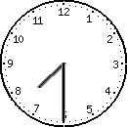
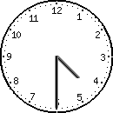
- 3.

It is __________________ It is __________________

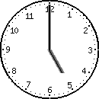
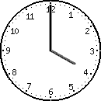
- 4.

It is __________________ It is __________________

