- Complete the sentences with There are or there is.

- ________ ______ three English teachers in my school.
- ________ ______ a cat in the garden.
- ________ ______ eleven boys in my class.
- ________ ______ a pen in my pencil case.
- ________ ______ a book on the table.
- ________ ______ a computer in my bedroom.

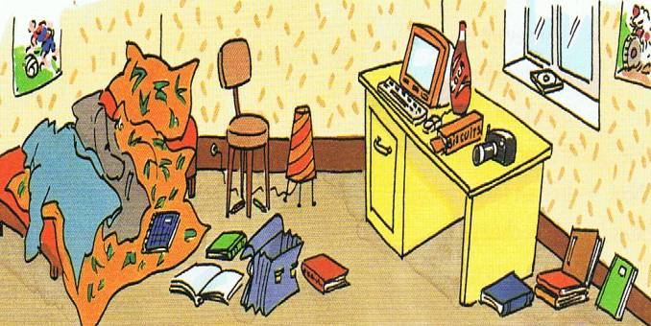



2. Complete the questions with Is or Are:

- _______ there a telephone in your house?
- _______ there any posters in your bedroom?
- _______ there any books on the table?
- _______ there a dog in the garden?
- _______ there any pencils in your pencil case?
- _______ there a piano in your classroom?
- _______ there pictures on the wall? _______there a chair next to the bed?

3. Look at the picture.
4. Answer the questions:
- Is there a cat?
- _______________________
- Are there any books?
- _______________________
- Is there a computer?
- _______________________
- Is there any video games?
- _______________________
- Is there a desk?
- _______________________
- Are there two beds?
- _______________________

5. True or false? Correct the false ones.
- There is camera on the desk.
- ________________________________
- There are books under the bed.
- ________________________________
- There is a bag between the books.
- ________________________________
- There are some clothes next to desk.
- ________________________________
- There some books next to the desk.
- ________________________________
- There is picture on the wall.
- ________________________________

6. Write ten sentences about your bedroom.
Example: There are some posters on the wall.
- _____________________________________________________
- _____________________________________________________
- _____________________________________________________
- _____________________________________________________
- _____________________________________________________
- _____________________________________________________
- _____________________________________________________
- _____________________________________________________
- _____________________________________________________
- _____________________________________________________

7. Complete the questions with a or any. Then answer the questions.

- Is there _____ a television in your kitchen?
- __________________________________
- Are there _____ toys in your bedroom?
- __________________________________
- Is there ______ piano in your house?
- __________________________________
- Is there ______ a clock in your classroom?
- ___________________________________
- Are there _____ restaurants in your town?
- ___________________________________
- Is there ______computer in your bedroom?
- ___________________________________
- Is there _______ in your pencil case?
- ___________________________________
- Are there _______ books in your living room?
- ___________________________________

