THAT IS MY VILLAGE
2. Tick the places in Jane’s village.
 | 
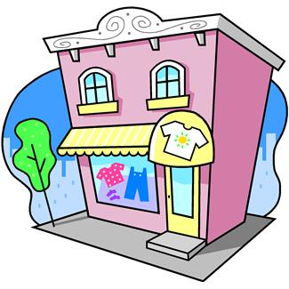 | 
 | 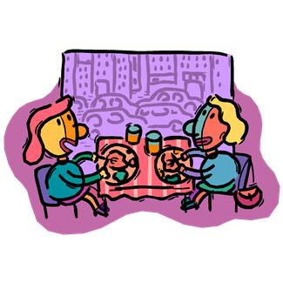
 | 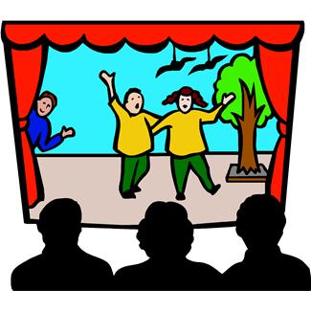
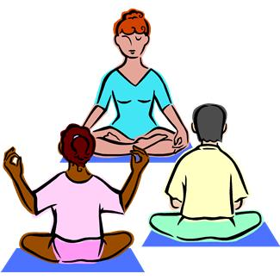 | 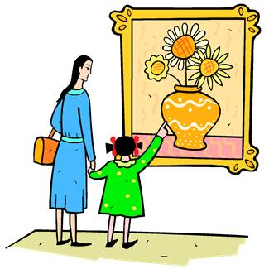

Hi, everybody,
My name is Jane. I live in a nice village in the north-east of London. My best friends, Sally and Paula, live there too, but I live in Church Street and they live in Town Square. We’re very happy here.
There aren’t so many places as in London, of course, but we’ve got lots to do. There’s a big community centre where you can do a lot of activities. My mother does yoga twice a week, my brother plays tennis with his friends and my and my friends have drama classes on Friday.
In my village there’s a small theatre where we can see films. Next to the theatre there’s a big cafeteria. Mr Smith is the owner and makes delicious sandwiches and pizzas. I sometimes have dinner with my family there.
My school isn’t very big, but it’s new and has got a nice playground. There aren’t any bookshops or clothes shops, but there’s a nice library where we can study and borrow books.
In my village there are two supermarkets and a wonderful park. There are lots of lowers and trees. I love jogging and riding my bike at weekends.


3. Answer these questions about the text:

1. Where’s Jane’s village?
……………………………………………………………………
2. Who’s the owner of the cafeteria?
……………………………………………………………………
3. When has Jane got drama lessons?
……………………………………………………………………
4. What is Jane’s school like?
……………………………………………………………………
5. How many clothes shops are there?
……………………………………………………………………
6. Where do Jane’s friends live?
……………………………………………………………………
7. What sport does her brother do?
……………………………………………………………………
8. How often does her mother go to the community centre? Why does she go?
……………………………………………………………………
9. Does Jane like her village?
…………………………………………………………………….

2. Say if the sentences are True or False. Correct the false ones.

1. You can’t do spot at the community centre.
……………………………………………………………………
2. There’s a big bookshop in the village.
……………………………………………………………………
3. People see films at the cinema.
……………………………………………………………………
4. Jane and her friends do yoga.
……………………………………………………………………
5. Mr Jones makes delicious pizzas.
……………………………………………………………………
6. Jane’s school is old and small.
……………………………………………………………………
7. The theatre is next to the school.
……………………………………………………………………

KEY
2.
All of them are false

1. YOU CAN DO YOGA AND TENNIS.

2. THERE AREN’T ANY BOOKSHOPS, BUT THERE’S A BIG LIBRARY.

3. YOU CAN SEE FILMS AT THE THEATRE.

4. JANE AND HER FRIENDS DO DRAMA/ JANE’S MOTHER DOES YOGA.

5. MR SMITH MAKES DELICIOUS PIZZAS.

6. JANE’S SCHOOL IS SMALL, BUT NEW.

7. THE THEATRE IS NEXT TO THE CAFETERIA.
2.

LIBRARY (YES) SUPERMARKET (YES)
CLOTHES SHOP (NO) BOOKSHOP (NO)
PARK (YES) CAFETERIA (YES)
SCHOOL (YES) THEATRE (YES)
COMMUNITY CENTRE (YES) MUSEUM (NO)

3. Answer these questions about the text:

1. IT’S IN THE NORTH-EAST OF LONDON.

2. MR SMITH IS THE OWNER OF THE CAFETERIA/ THE OWNER OF THE CAFETERIA IS MR SMITH.

3. SHE HAS GOT DRAMA CLASSES ON FRIDAY.

4. HER SCHOOL ISN’T BIG, BUT IT IS NEW AND HAS GOT A NICE PLAYGROUND.

5. THERE AREN’T ANY CLOTHES SHOPS.

6. HER FRIENDS LIVE IN TOWN SQUARE.

7. HE PLAYS TENNIS.

8. SHE GOES THERE TWICE A WEEK BECAUSE SHE DOES YOGA.

9. YES, SHE THINKS IT’S A NICE PLACE AND SHE’S VERY HAPPY AND THERE’S A LOT TO DO THERE.

