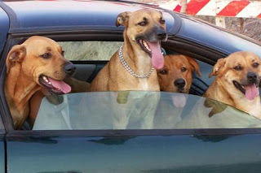

**Teen Stars**

**that Love Dogs**

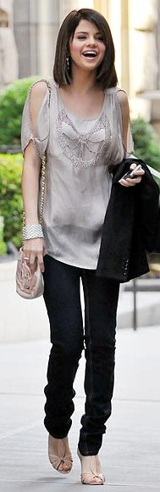

Four Selena’s dogs

**Selena Marie Gomez** is a Disney star.

Children all over the world know her as *“Alex Russo”* – a beautiful wizard from Waverly Place. But when Selena is at home, she has got a new role – dog lover.

Selena and her family have got five dogs: Chip (Welsh Corgi), Fina (Rhodesian Ridgeback), Willie (**unknown breed**), Wallace (German Shepherd Boxer mix) and Chazz (unknown breed). All Selena´s dogs are from a **shelter** except Chazz. Chazz comes from a beach in Puerto Rico.

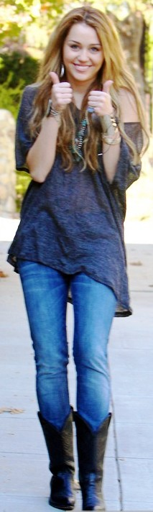

The funny thing is that all Selena’s dogs are of the same colour – brown. When

Selena isn´t at work she likes to play with her **pack**. However, one dog

is very close to this star’s heart. It’s Willie who **has a hold on** Selena’s heart.

**It’s no secret** that **Miley Cyrus** loves dogs. When she goes out she always has one of her five dogs with her. Lila, a cute Yorkshire Terrier, is the oldest dog in the **pack**. Lila has got a collection of beautiful dresses just like her mom, Miley. Floyd, a miniature Huskey, goes running with Miley. Ziggy, an English Bulldog, was a present for Miley’s boyfriend. Happy, a **tiny** Rottweiler Beagle mix, comes from a box left in front of the supermarket! And the last dog, Mary Jane, comes from a Hollywood **shelter**. Miley really has a **soft spot for** dogs!

**GUESS THE MEANING**

**Unknown breed** means **It’s no secret** means

a) we don’t know if the dog is a terrier or a bulldog a) it is a small secret

b) we don’t know the dog’s name b) it is not a secret

c) we don’t know the dog’s colour c) it is a big secret

**Shelter** is **Has a hold on Selena’s heart** means

a) a special pet shop only for dogs a) Willie sleeps on Selena’s heart at night

b) a farm for dogs b) Willie sits on Selena

c) a home for dogs from streets c) Willie is Selena’s favourite dog

**Pack** is **Miley has a soft spot for dogs** means

a) a dog toy a) dogs are Miley’s favourite food

b) dogs that live with one family b) Miley wants to have all dogs from the world

c) a celebrity’s family c) Miley loves to help dogs

**Which Miley’s dog is tiny:**

a) b) c)

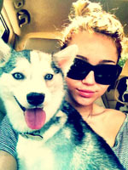

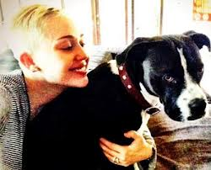

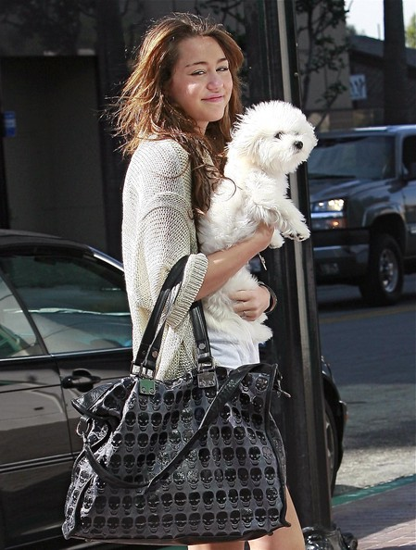

**TRUE OR FALSE?**

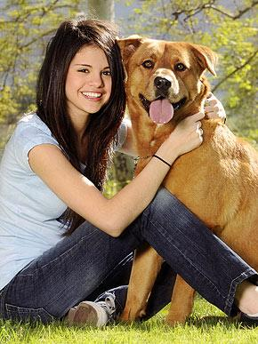

1 Selena and Miley have got eleven dogs. T F

2 Chip and Fina aren´t from a shelter. T F

3 Wallace is Selena’s favourite dog. T F

4 Chazz is from Mexico. T F

5 Selena’s dogs are brown. T F

6 Miley has got five dogs. T F

7 Lila is a girl. T F

8 Ziggy is a present from Miley’s boyfriend. T F

9 Happy is from a shelter. T F

10 Miley likes to help dogs. T F

**REWRITE FALSE SENTENCES**

______________________________________________________________________________________________________________________________________________________________________________________________________________________________________________________________________________________________________________________________________________________________________________________________________________________________________________________________________________________________________________________________________________________________________________________________________________________________________________________________________________________________________________________________________________________

**CHALLENGE**

**Read the text and complete the gaps with one word.**

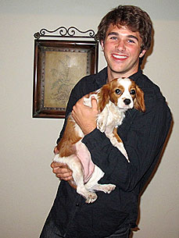

likes spot old dog shelter

pack got breed years

Popular Disney Channel Star, Hutch Dano, ______________ dogs.

His favourite _____________ is Bella,

two years ___________ Cavalier King Charles Spaniel.

A busy actor has _______________ two other dogs as well,

five years old Puggle Buddy

and ten ____________ old Chance (unknown ______________). ***Bella, Cavalier King Charles Spaniel***

Hutch has a soft ______________ for dogs and Chance comes from a ___________________.

Hutch’s dogs are a very happy _____________________ full of energy.

But Hutch has also got two cats. Hutch loves animals.