**SUPERSTITIONS**

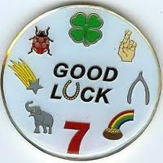

“A superstition is an irrational belief”

Match the beginnings and endings of these sentences making use of first conditional :

1. If you find a clover plant with four leaves, ...
2. If you want your house to attract luck, ...
3. You will have seven years bad luck ...
4. You will be unlucky ...
5. In Britain, if you meet a black cat, ...
6. You will avoid bad luck ...
7. If you put money in the pockets of new clothes, ...
8. You will be unlucky ...
9. If you spill some salt on the table, ...
10. You will be lucky ...
11. ... if you break a mirror.
12. ... you will be lucky.
13. ... throw some salt over your shoulder.
14. ... if you walk under a ladder.
15. ... if you touch wood.
16. ... you will be lucky.
17. ... you will be lucky.
18. ... put a horseshoe right up over the door.
19. ... if you open an umbrella indoors.
20. ... if you catch falling leaves in autumn.