
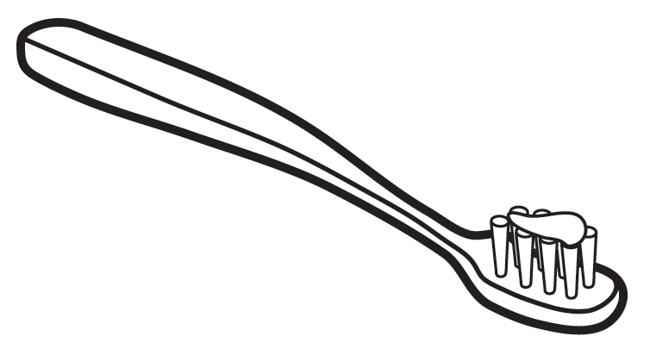
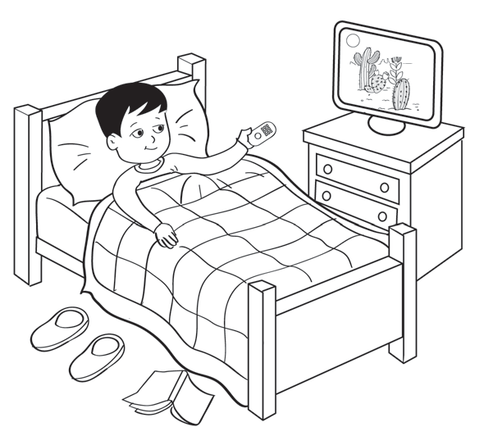
Worksheet 2.4b
Keeping healthy
Name:
Date:
Write and draw how to keep healthy.
Cambridge Primary Science 3
55
© Cambridge University Press 2014
Do
Don’t

Brush your teeth.

Stay up late.

