Reading and Writing Large Numbers

In reading and writing large numbers we group place values into periods ‘ones or unit’, ‘tens’, ‘hundred’, ‘thousand’, ‘10 thousand’, ‘100 thousand’, ‘million’, ’10 million’, ‘100 million’, are periods.

For example:
Ones/Unit = 1
Tens = 10
Hundred = 100
Thousand = 1,000
10 Thousand = 10,000
100 Thousand = 100,000
Million = 1,000,000
10 Million = 10,000,000
100 Million = 100,000,000
The below diagram will help us to get the better concept on facts about reading and writing large numbers.
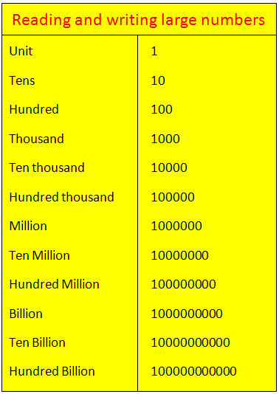

So, while reading or writing a large number we need to start from the left side with the largest group and move to the right side.
Reading and writing large numbers in words in thousand and hundred:
(i) 3,019 - Three thousand nineteen
(ii) 5,059 - Five thousand fifty-nine
(iii) 8,782 - Eight thousand seven hundred eighty-two
(iv) 41,018 - Forty-one thousand eighteen
(v) 52, 739 - Fifty– two thousand seven hundred thirty-nine
(vi) 621,011 - Six hundred twenty-one thousand eleven
(vii) 530,008 - Five hundred thirty thousand eight
(viii) 765,941 - Seven hundred sixty-five thousand nine hundred forty-one

Reading and writing large numbers in words in million, thousand and hundreds:
(i) 6,254,745- Six million two hundred fifty-four thousand seven hundred forty-five
(ii) 31,286,271 - Thirty-one million two hundred eighty-six thousand two hundred seventy-one
(iii) 731,256,835 - Seven hundred thirty-one million two hundred fifty-six thousand eight hundred thirty-five
(iv) 651,356,851 - Six hundred fifty-one million three hundred fifty-six thousand eight hundred fifty-one

