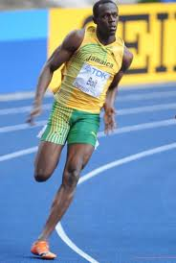
Did You Know ? (7)
Usain Bolt

Here are 7 interesting facts about the man you probably did not know:

1. He is a big fan of football star Christiano Ronaldo and has offered him some sprinting tips. Ronaldo himself was overjoyed with the offer as he too is a big fan of the Athetics superstar. Though, his favourite footballer is Ruud Van Nistelrooy.
2. He is the youngest ever gold medalist of the World Junior Championship, winning the 200 m at age of only 15. He is also the first and the only junior athlete to break sub 20 seconds in 200 metres.
3. At 2008 Olympics, the 9.69s Olympic record was set not only without a favorable wind (0.0ms) and a slow reaction time (0.165s) but also with a celebration at the last 20 metres which significantly slowed him down and his shoelace was untied. Even his 2012 final race got off to a slow start, with Justin Gatlin (USA) taking the lead, but Bolt turned on his turbo-boosters just after the half way mark to leave his competition eating dust.
4. Other than just being the fastest man on the planet, Bolt operates his own restaurant in Kingston, Jamaica called “Tracks And Records.”
5. Bolt also has many products in conjunction with international brands. He has his own clothing line with Puma, his own watch made by Hublot, and his own headphone range ‘Soul by Usain Bolt’.
6. He is one of the most marketable sportsmen in the world, and the most valuable name in the field of Athletics. His renewed contract with Puma is estimated at around $5 million a year, comfortably the biggest endorsement contract ever signed by a track and field athlete, is at par, according to The Guardian, with Christiano Ronaldo's contract with Nike.
7. Before he was a sprinter, Usain Bolt’s first sport was cricket where he specialized as a fast bowler. If had not been tearing up the track today, he might have been burning up the pitch. His love for the game still persists and is a fond admirer of Chris Gayle, Sachin Tendulkar and Waqar Younis. In a charity game, he clean bowled and later, thrashed Chris Gayle for a six.

Exercise 1. Read the text and match the headlines with the paragraphs.

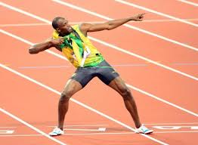
1. First steps in sport.
2. The youngest champion.
3. Restaurant owner.
4. Football fan.
5. Owner of trade marks.
6. Rich man.
7. The fastest man.

Exercise 2. Read the sentences and decide: true (T) or false (F)

- He comes from Brazil. ………
- He has gold medals. …………
- He is a big fan of baseball. ……….
- His favourite football player is Nistelrooy. ……….
- He won the 200 m over the age 20. ……….
- He is now the slowest man in the world. ……….
- He is the owner of the disco club. ……….
- He has his own products made by famous brands. ……….
- He is a very rich sportsman. ……….
- Firstly hi played squash. ……….
