**1. Match the questions with the answers.**

***Where can I buy….***

At the baker´s.

At the florist´s.

At the book shop.

At the grocer´s.

At the butcher´s.

At the pet shop.

At the post office.

At the newsagent´s.

1. … a book?
2. … food for my fish?
3. … bread?
4. …meat?
5. … some tulips?
6. … tomatoes and brocolli?
7. …a magazine?
8. … a stamp?

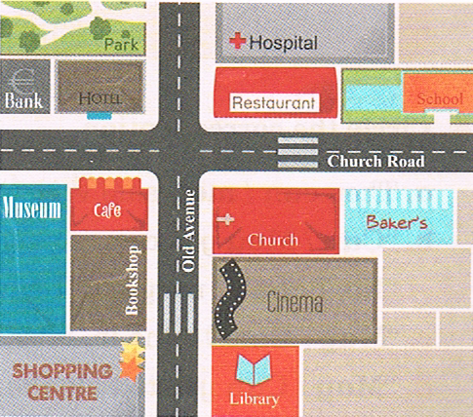

**2. Look at the city plan and complete the sentences.**

1. The school is ____________the restaurant.
2. The baker´s is ___________ the school.
3. The cinema is ___________ the church and the library.
4. The café is ________ of Church Road and Old Avenue.

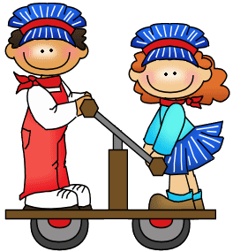**3. Complete the questions and then look at the city plan and write the answers.**

**Bob is at the library.**

Bob: Excuse me, where _____ the museum?

Officer: _______ along Old Avenue and ______ the first ______ on the left.

The museum is ________ the café.

**Kelly is at school.**

Kelly: Excuse, me, where ______ the park?

Officer: ________ _________ Church Road and ______the first ______ on the ________. The park is ______ the hospital.