**Present perfect**

1. **Make sentences that fit the pictures: Use the present perfect tense.**

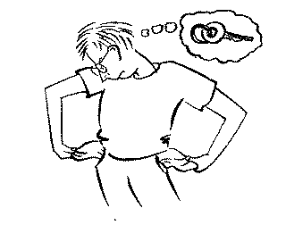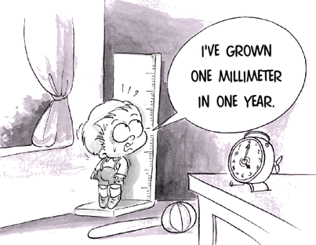

__________________________________________________________________________________

__________________________________________________________________________________

1. **They have already had lunch**

**Find a partner and ask the following questions:**

1. Would you like something to eat No, thanks. I’ve just had lunch.

(I/just/have/lunch)

2. Do you know where Julia is? Yes, _______________________

(I/just/see/her)

3. What time is Franziska leaving? ___________________________

(She/already/leave)

4. What is in the newspaper today? I don’t know._________________

(I/not/read/it)

5. Are you coming to the cinema with me? No, ________________________

(I/have/already/see/film)

6. What have you done this morning? I__________________________