

Affirmative
I am working you are working he/she/it is working we / they are working

Negative
I am not working you are not working he/she/it is not working we / they are not working

Interrogative
Am I working? Are you working? Is he/she/it working? Are we / they working?

We use the present continuous to talk about:

- things that are in progress now, at this moment.

- temporary actions or situations.
eat
drink
buy
swim
talk
play
read
build

Example: There is a boy eating an ice-cream.
- _________________________________________________________________
- _________________________________________________________________
- _________________________________________________________________
- _________________________________________________________________
- _________________________________________________________________
- _________________________________________________________________
- _________________________________________________________________
- _________________________________________________________________
- _________________________________________________________________



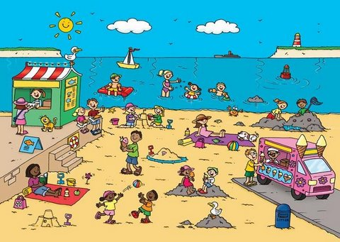

What are they doing? Look at the picture and write sentences. There are some verbs in the box that will help you.



B) Complete the sentences with the correct form of the present continuous, using the verbs in brackets.

- Mary _____________ (read) a book.
- Susan _____________ (talk) with Mark.
- Catherine and Mark _____________ (draw) a flower.
- he _____________ (ask) a question.
- The boys _____________ (play) football.
- Margaret and I _____________ (eat) an ice-cream.
- Mum _____________ (cook) dinner.

C) Put the following sentences into the negative form.

- Rita is writing a letter. _______________________________________________________
- Sally is reading a book. ______________________________________________________
- Lucy´s husband is cooking dinner. _____________________________________________
- Catherine is singing a song. ___________________________________________________
- Mark is mending his friend´s bike. _____________________________________________
- My aunt is decorating her house. ______________________________________________

D) Complete the sentences below writing the verbs in brackets in the present continuous.

- _______ you _______ (read) a book?
- _______ she _______ ( watch)? – Yes, she _______ a cartoon.
- _______ the sun _______ (shine)?
- _______ the birds _______(sing)?
- Why _______ he _______ (cry)?
- _______ the woman _______ (have) a shower?
E) Answer the following questions building logical sentences using the verbs in brackets in the present continuous.

- What are you doing at 1 p.m.? (eat)
- _____________________________________
- What are the students doing at 4 p.m.? (read)
- _____________________________________
- What are you doing at the moment? ( answer questions)
- _____________________________________
- What is your mother doing at the moment? (cook)
- _____________________________________

