1.
Name the structures labelled A, B, C, D and E.

2.Which of the following is correct:
When we inhale
(a) our intercostal muscles contract and our ribs move down
(b) our diaphragm muscles contract and the ribs move up
(c) our diaphragm muscles contract and the ribs move down
(d) our intercostal muscles contract and the diaphragm muscles relax.

3.What happens to the depth and rate of breathing during increased physical activity?

4. Why does exhaled air contain more carbon dioxide than inhaled air?
__________________________________________________________________________________________________________________________________________________________________________

5. In an experiment, three glass bell jars were set up as shown in the diagram
At the end of the experiment, which bell jar has the most oxygen and which has the least?
6. The diagram shows a model which can be used to demonstrate breathing.
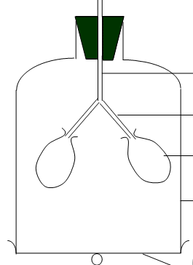
Name the part of the body represented by: balloon, glass tube, bell jar, sheet of rubber.

7. State one benefit of including vegetable fibre (roughage) in the diet.

8. (a) Which vitamin helps to maintain resistance to infectious diseases?
(b) Name two foods which are a good source of this vitamin.

9. (a) Which vitamin is necessary for the proper development of the skeleton?
(b) Name two foods which are a good source of this vitamin.
10. Look at the diagram and label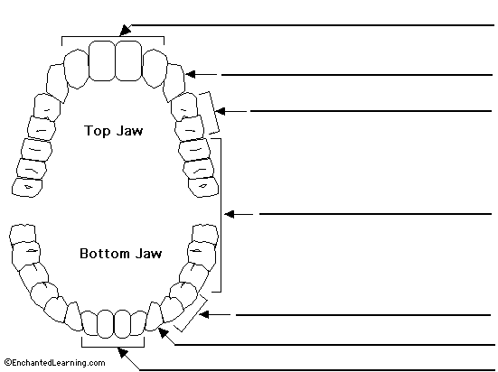
11. Look at the diagram and label
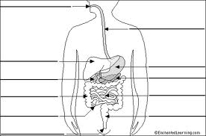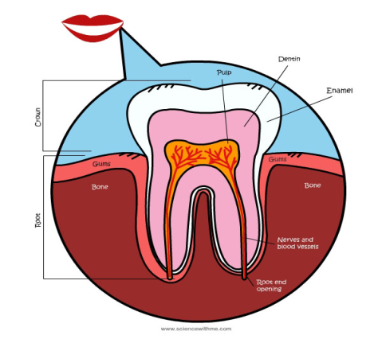
12. Name five ways to look after your teeth.
__________________________________________________________________________________________________________________________________________________________________________
13. Label follow parts of the skeleton: skull, collar bone, ribs, pelvis, thigh bone, knee cap.
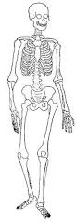 Why you have a skeleton?
14. Can you explain life cycle of a human. Name the four main stages.
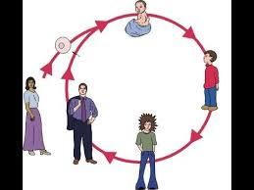
What happens to a boys and girls body during puberty?
__________________________________________________________________________________________________________________________________________________________________________
15. What is the function of the kidney?
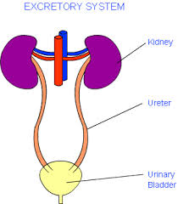
16. Give three advantages and three disadvantages of micro-organisms.
_____________________________________________________________________________________

