I–my We–our
You–your They-their
He–his
She–her
It-its


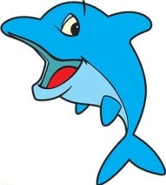

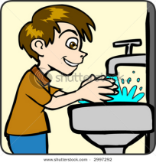
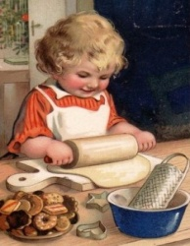
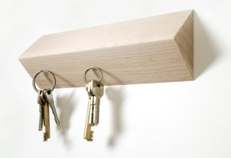
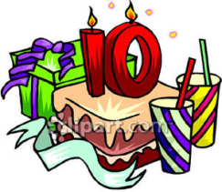

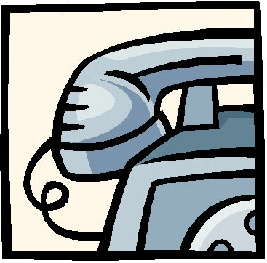
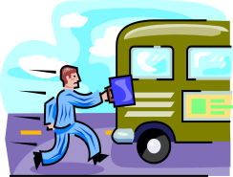

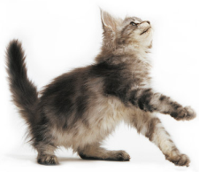
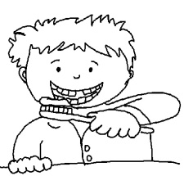
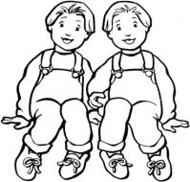
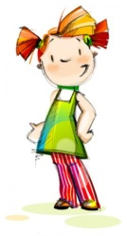
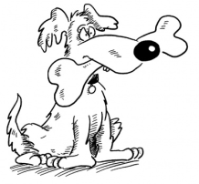
1. My dad is a writer. It is
______
computer.
2. Jacob is washing ___ hands.
They are
very dirty.
3. Ann is baking cookies for
______
mother.
4. They put ______ keys near the
door.
5. I’m 10 today. It is _______
birthday.
6.Whay is ___ mum? She is an
architect.
7. Could you give me ________
telephone
number?
8. Nick is late because he missed
_______
bus.
9. I can’t go out. I must do _______
homework.
10. Lucie loves ____ new kitten.
It is so
funny!
11. Tom brushes ___ ___ teeth twice
every day.
12. They are twins. ______names are Tom and Philip.
13. Where‘s Karol? She is in ______
room.
14. It is my dog and ______ name is Barky.

