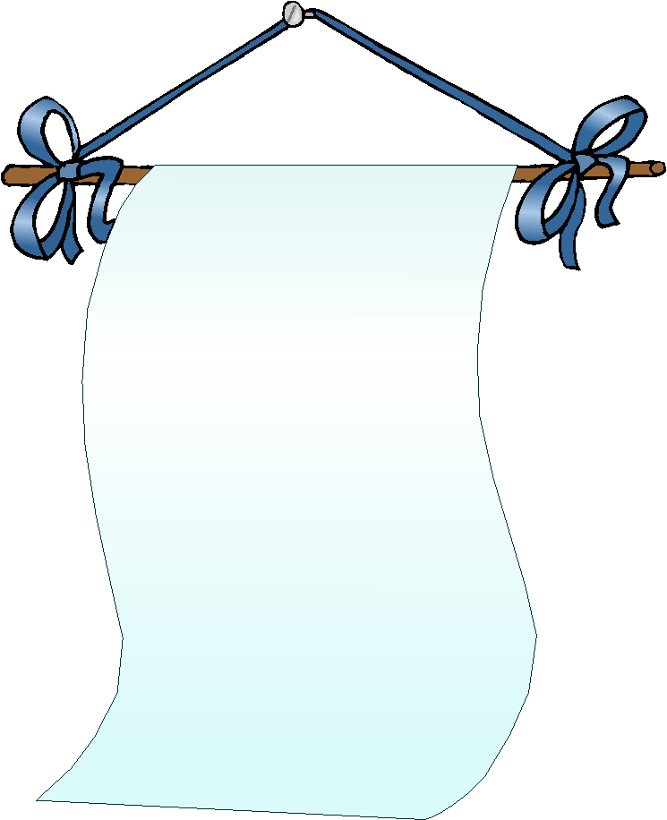
Name: __________________
Date: _____/ _____ / ______
Mark:

Teacher:
MY
YOUR
HIS HER
ITS
OUR
YOUR
THEIR

1. Fill in the blank spaces using the possessive adjectives: my, your,
his, her, its, our, your, their.

- Tim is a boy and __________ surname is Forbes.
- The cat is a pet. __________ ears are black with white spots.
- I’m a designer and __________ favourite TV channel is “Fashion”.
- It is raining and you haven’t got __________umbrella with you.
- Nanny and you are twins. __________ parents are Mr and Mrs Brown.
- Take these colouring pencils. I like __________ colour.
- The girl is crying because __________ doll is dirty.
- You and I love reading! Crime writing is __________ favourite!
- Sam isn’t Santa Claus but __________ beard is white.
- Sarita is Spanish but __________ mother is Portuguese.
- That dog is mine. __________ name is “Blacky”.
- Those pupils have got new CDs. __________ favourite singer is Pavarotti.
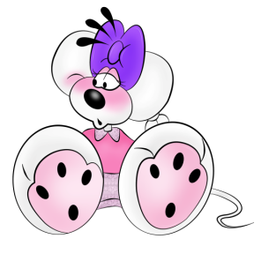
- This is Bryan Adams. You and I like this singer. Bryan Adams is __________ favourite singer.
- Scott and you like surfing. It is __________ favourite sport.
- I’m Gillian and __________ surname is Anderson.

- Hey, you! is this __________ car?

Name: __________________
Date: _____/ _____ / ______
Mark:

Teacher:
MY
YOUR
HIS HER
ITS
OUR
YOUR
THEIR

1. Fill in the blank spaces using the possessive adjectives: my, your,
his, her, its, our, your, their.

- Tim is a boy and __________ surname is Forbes.
- The cat is a pet. __________ ears are black with white spots.
- I’m a designer and __________ favourite TV channel is “Fashion”.
- It is raining and you haven’t got __________umbrella with you.
- Nanny and you are twins. __________ parents are Mr and Mrs Brown.
- Take these colouring pencils. I like __________ colour.
- The girl is crying because __________ doll is dirty.
- You and I love reading! Crime writing is __________ favourite!
- Sam isn’t Santa Claus but __________ beard is white.
- Sarita is Spanish but __________ mother is Portuguese.
- That dog is mine. __________ name is “Blacky”.
- Those pupils have got new CDs. __________ favourite singer is Pavarotti.
- This is Bryan Adams. You and I like this singer. Bryan Adams is __________ favourite singer.
- Scott and you like surfing. It is __________ favourite sport.
- I’m Gillian and __________ surname is Anderson.
- Hey, you! is this __________ car?

Answer key.
- his
- its
- my
- our
- Your
- their
- her
- our
- his
- her
- its
- their
- our
- our
- my
- your

