REVISION TEST: Past Simple and Past Continuous

Name:

Date:

**1. Read the information about Margaret´s life in 1970. Write past simple statements (✓) and negatives (🗶) using the information below.**

1 ✓ work in a shop __________________________________

2 🗶 like her job ____________________________________

3 ✓ live in a flat ____________________________________

4 🗶 want a house ___________________________________ **7/**

5 ✓ prefer flats _____________________________________

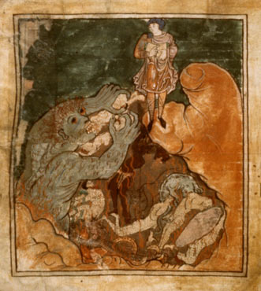

6 🗶 stay with her parents ______________________________

7 ✓ try to go to university _____________________________

**2. Read the text about one of the most famous English poem *Beowulf.***

**Complete the text using the correct form of the verbs in brackets.**

Beowulf _________ (be) a great fighter 1000 years ago. He won many battles against monsters and dragons.

Grendel ________ (be) a terrible monster from Denmark. He ______ (have) big teeth. Grendel _______________ (not sleep) and _______________ (not eat). He drank blood. Danish king paid Beowulf to kill Grendel. Beowulf ________________ (go) to Denmark, fought the monster and killed it. The king _________________ (give) Beowulf a lot of money. Beowulf _________________(leave) Denmark . He ________________(become) a King.

Beowulf died because a dragon killed him. **8/**

**3. Grace is thinking about her holiday she had last week. Complete the statements with the verbs from the boxes. Use past continuous.**

Can you believe it? This time last week I was on holiday ...

1. I ____________________________ (sit) in a café.

2. I ____________________________ (wear) sunglasses.

3. My friends and I ______________________ (drink) lemonade.

4. The sun ___________________________ (shine).

5. It _______________________________ (not rain). **5/**

**4. Complete the text with the verbs in brackets. Put the verbs in the correct tense. Use past simple or past continuous.**

When I ………………………………. (sit) down,

the teacher ………………………. (come) and …………………………………………………. (give) us tests.

We all ………………………………… (start) shouting.

While we ……………………………………. (write) the tests,

someone …………………………………… (call) to school and ……………………………………. (inform) the headmaster about the bomb in the building. We all ……………………………………………. (run) outside.

We ……………………………… (feel) happy.

Soon the police ……………………………….. (arrive) and ……………………………………… (search) the building.

While they …………………………………………… (look) for the bomb,

we ……………………………….. (stand) in front of the school.

It ………………………………………… (be) cold and

I ………………………………………. (not have) a coat or jumper.

While we …………………………………………. (shiver) outside,

it …………………………………… (start) to rain.

We ……………………………………………… (stand) there for two hours.

When we …………………………………………….. (return) to the classrom,

we …………………………….. (be) cold and wet.

Well, thank you very much for this silly joke.

**20/**

