
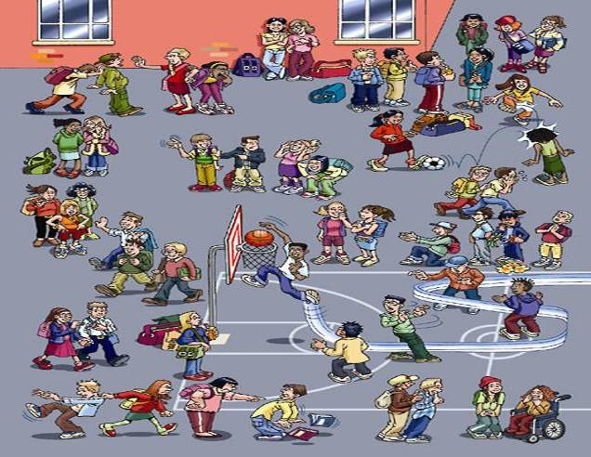
Name: …………………………………….. Date: ……/……/……
Class: ……………. Number: ………..
Mark: ……………… Teacher: …………………..
John was playing basketball when I saw him.
- Imagine you were at the playground yesterday. What were they doing?
Look at the picture and write sentences. There are some verbs in the box that will help you.

Example: When I saw Susan she was shouting.
Past Simple and Past Continuous together:

Past continuous refers to the longer background action and the Simple Past to the shorter action that happened in the middle of the longer one or interrupted it.
Run smile fight playing run hit kick talk push pull pray cry shout wave

Put the following sentences into the correct tense, Simple Past or Past Continuous:

- We ___________ (go) down the road at 100 Km/h when the wheel ________ (fall) off.
- She nearly ________ (have) a heart attack when she _______ the lion.
- My mother _________ (get) dressed when she _________ (feel) a pain in her chest.
- She _________ (fill) in a questionnaire when the pen _________ (run) out of wink.
- Susan __________ (not/see) her friend because she ________(face) the other way.
- Mike ________(fall) off the ladder while he __________ (paint) the ceiling.
- While Ann _________ (cook) dinner, the phone _________ (ring)
- Susan _________ (wait) for me at home when I _________ (arrive) yesterday.
- What ___________ (you /do) at this time yesterday?
- I ______________ (see) carol at the party. She ___________ (wear) a beautiful dress.
- I ____________ (break) a plate last night. I ___________ (do) the washing up
- (you/watch) TV when I _________ (arrive)?
- Last night I ____________- (read) in the bed when suddenly I _________ 8hear) a scream.
- We __________ (not/go) out because it ___________rain.
- We ___________8do) our homework while our mum _________(cook) dinner.
- I ________ (see) Tom in the park. He _________(sit) on the grass and ________ (read) a book.

