Fill in the blanks with the correct verb in the past simple or continuous. Choose from the list:
PAST: SIMPLE OR CONTINUOUS?
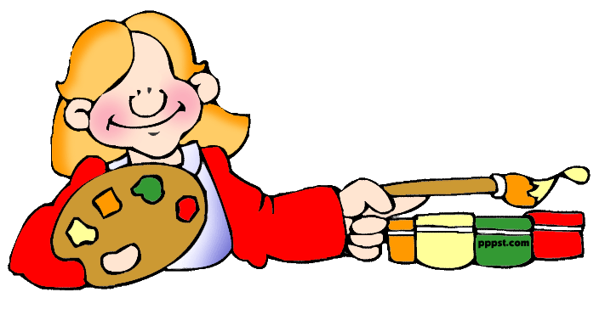 | 1. Jane ……………… …………………… yesterday. She ……  ……………… a nice picture. | 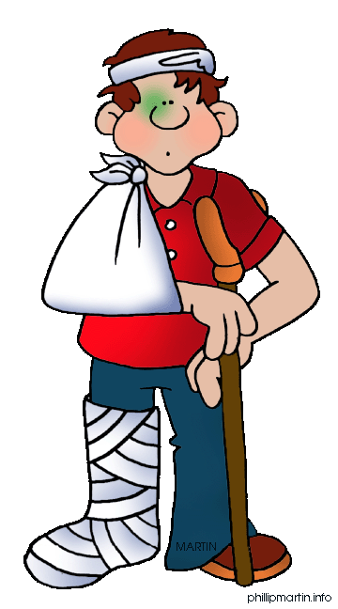 | 2. Tim ……………… badly and …………… his leg and arm when he ………………… to school.
3. Last Halloween John ………………… himself as  Frankenstein. He ……………………… so frightening! | 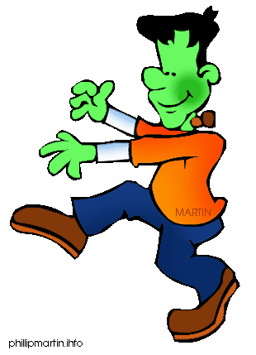 | 4. Sue ………………… to the psychologist yesterday. She ………………………… (not) what to do when she …………… school. | 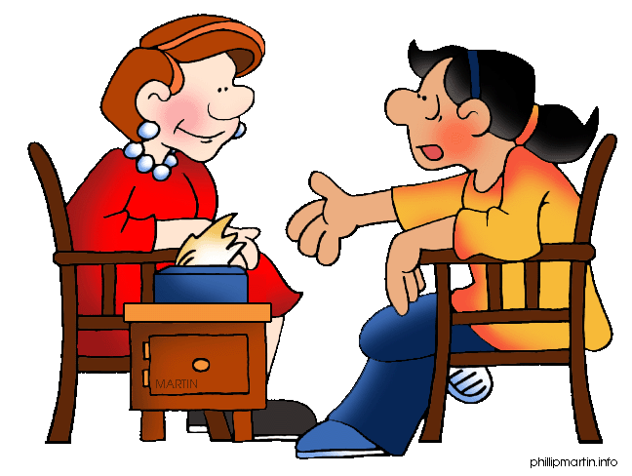
 | 5. Sally ……………… a great speech on politics last week. Everybody ………………………… listening to her. |  | 6. John …………………  his maths exam. He ……………… really happy because he ……………… the best mark of his class.
7. Dan ………………  …………… football for two hours after school. In fact, he …………………… two goals! | 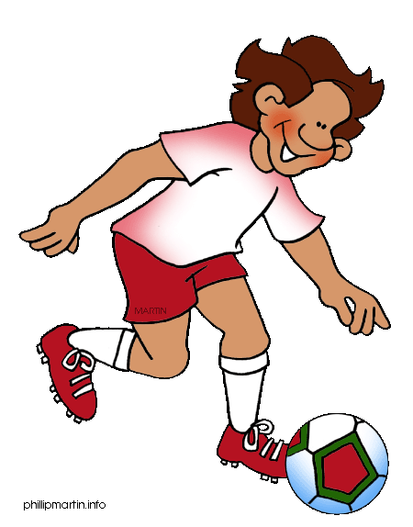 | 8. Bob …………………  the Internet last Monday. He ………  ………………………… for information for his weekly project. | 
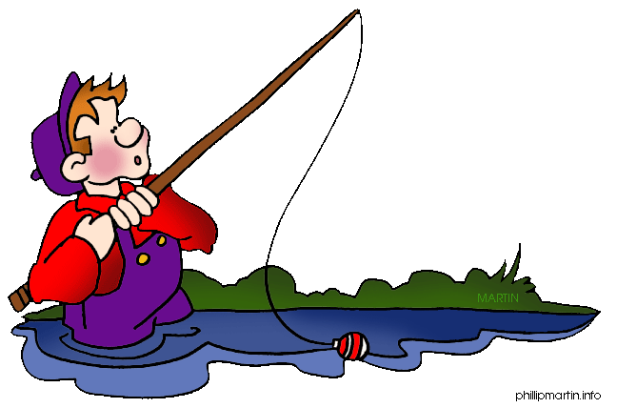 | 9. Jack ………………  the afternoon fishing, but he ………………………… (not) any fish. She ………………… so disappointed! | 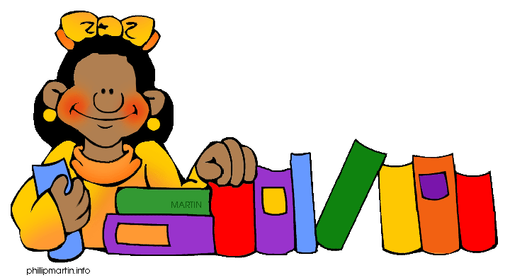 | 10. Pam ……………… to the library on Tuesday. She ………… some books to prepare her final exams.
11. Carl ………………  ……………… letters to his pen pals in the morning and then he ……………  them in the afternoon. | 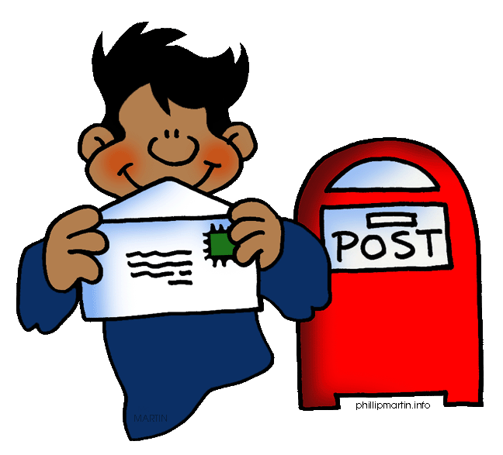 | 12. The children ………………………… yesterday morning. They ………………… a good time with their toys. | 
 | 13. Mum …………… a big turkey for dinner. She ………  ……………………… it for hours and it ………………………… delicious! | 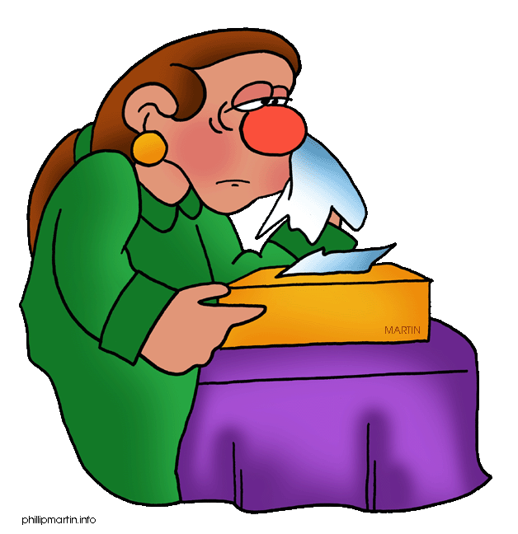 | 14. Sarah ……………… (not) well yesterday. She ……………… a runny nose and a headache, so she ………………… Dr Jones who ………… her some pills.

ENJOY
BORROW
CATCH
GIVE
RUN
SCORE
PLAY (2)
TALK
FALL
WRITE
FEEL
PASS
LEAVE
PAINT (2)
CALL
MAKE (2)
GET
DISGUISE
BE (2)
FISH
POST
TASTE
LOOK (2)
SURF
HAVE (2)
BREAK
COOK
GO

- WAS PAINTING- PAINTED
- FELL- BROKE- WAS RUNNING
- DISGUISED- LOOKED
- WAS TALKING- DIDIN’T KNOW- LEFT
- MADE- ENJOYED
- PASSED- WAS- GOT
- WAS PLAYING- SCORED
- WAS SURFING- WAS LOOKING
- WAS FISHING- DIDN’T CATCH- WAS
- WENT- BORROWED
- WAS WRITING- POSTED
- WERE PLAYING- HAD
- MADE- WAS COOKING- TASTED
- DIDN’T FEEL- HAD- CALLED- GAVE

