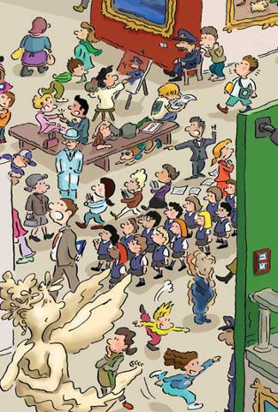

REMEMBER:

- We use simple past to talk about a complete action
- ( long or short)

- We use the past continuous for actions which were not complete at a past time.

E.g. At 8.00, when Carl came home, I was reading.
A) Imagine you were at the museum yesterday. Look at the pictures and write sentences. Start like this: While / when I …..

- _________________________
- _________________________
- _________________________
- _________________________
- _________________________
- _________________________
- _________________________
- _________________________
- _________________________
- _________________________
- _________________________

- When I arrived home the baby cried.
- At midnight, I drove to England.
- Bill watched T.V. when Ann called him.
- It was a nice evening, so she was walking home from work.
- While I wrote a letter the telephone was ringing.
- When I went out, it rained.
- When we was asking, the were saying ”No”
2. The following sentences are wrong. Correct the mistakes:
3. Complete the following sentences with Past Simple or Past continuous:

- I _________ (drive) my car when I _________ (have) the accident.
- They _______ (have) so much fun at the party, they __________ (decide) to stay.
- What ________ (you/do) when he _________ (arrive).
- Why _________ (You/run) when I ________ (see) you yesterday?
- When the teacher ________ (arrive) they _______ (play) in the back of the classroom.
- I ________ (read) a book while my mother ________ (cook)
- I ________ (paint) the wall when I _______ (fall) .
- We ________ (walk) when we _______ (ear) a scream.

