Past Continuous
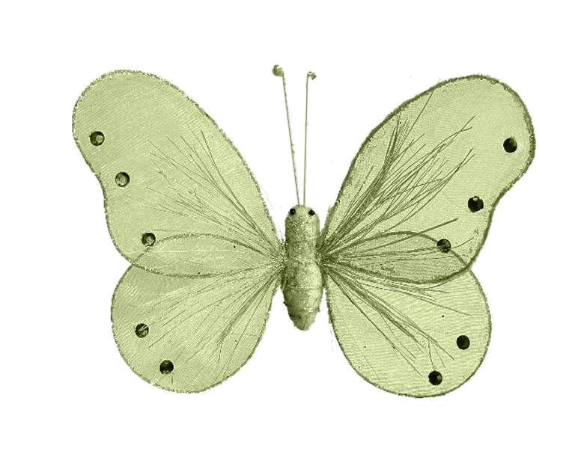
- What was happening at 8 o’clock yesterday evening? Use the clues and complete the sentences.

- We make the Past continuous with was / were + … ing
Examples:
- At 8 o’clock I was waiting for a train.
- What were you doing?
- I wasn’t at the bar last night at 11 o’clock.
- We use the Past continuous to say what was (not) happening around (before and perhaps after) a past time.
Example:
- “What were you doing at 8.00? Were you watching T.V.?
- At 8.00? No, I wasn’t watching T.V. I was playing cards.
Listen to a CD / watch T.V.

Jed was listening to a CD. He wasn’t watching T.V.
Swim / run

Ann _______________
__________________
Play volleyball / study

Mark _____________
__________________
drive / repair

Mike _____________
__________________
Read a book / cycle

Tim and Vera_________
__________________
B) Write questions:

- Were you reading a book?
At 10.00 I was reading ( a book)

- ____________________?
When I saw Peter he was eating. (What)
- ____________________?
When I went to her house she was writing (letters)
- ____________________?
At 8.00 Ann was cooking. (What)
- ____________________?
At midnight I was driving (to London)
C) What were you doing at 9 O’clock last night?

________________________
________________________
________________________
________________________
________________________

