



We make the Past Continuous with was / were+ …ing
AFFIRMATIVE
I / he / she / it was singing
you / we / they were singing
NEGATIVE
I/he/she/it wasn´t singing
you / we / they weren´t singing
INTERROGATIVE
Was I / he / she / it singing?
Were you / we / they singing?


We use the Past Continuous to express:
- Actions in progress at a moment in the past.
E.g.: last night at 9 o’clock I was reading a book.
- Describing a scene.
E.g: It was an awful morning. It was raining heavily and the wind was blowing.
c) Actions happening at the same time in the past.
E.g.: My mother was cooking while I was reading a book.


CONNECTORS: as, because, when, while
- What was Mark doing yesterday at …. ? Look at the pictures and write sentences .
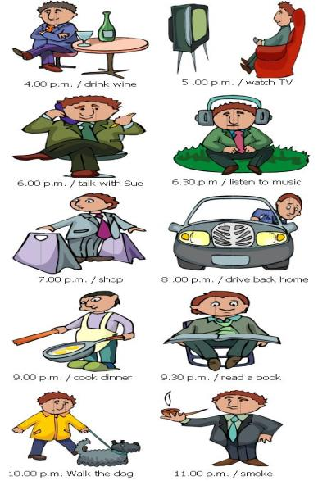
Example: At 4 o´clock he was drinking wine.
- ______________________________
- ______________________________
- ______________________________
- ______________________________
- ______________________________
- ______________________________
- ______________________________
- ______________________________
- ______________________________
- ______________________________

- Complete with the Past Continuous:
- I _______(play) cards while Mark _______(watch) TV.

- _______ (they listen)to music while they _______(study)?

- The bees _______(make) honey while the Sun _______ (shine).

- She _______(not/ learn) French while she _______(live) with us.

- Write sentences as the example using while.
Example : Mother / write / a letter – father / shave
My mother was writing a letter while my father was shaving.

- Mark / ride / a bike – sister /play / piano
__________________________________________

- Susan / draw / pictures – grandmother / tell / us / a story
__________________________________________

- It / rain – we / play / tennis
_________________________________________
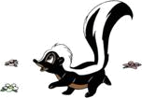
- Write questions:
- ______________________________________________________________________?
At 8 o’clock I was watching TV.

- ______________________________________________________________________?
When I saw Mark he was playing football.

- ______________________________________________________________________?
I was having a shower while my mother was cooking dinner.

- ______________________________________________________________________?
When we arrived children were playing cards.

- ______________________________________________________________________?
At midnight Mary and Sue were sleeping.

- Build up sentences with the correct word order. The verb should go into the Past Continuous.
- loudly / talk / very / Susan . _________________________________________________________
- and / lunch / Mary / have / John _____________________________________________________
- accident / there to be/ an __________________________________________________________
- write / she / not? ________________________________________________________________
- with / she / go / who? ____________________________________________________________
- the / stay / Linda / at / hotel? _______________________________________________________

