back of the head

chin

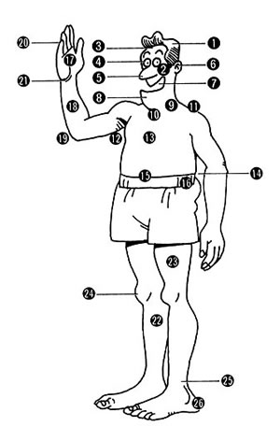

ear

side

palm

thigh

cheek

ankle

shoulder

stomach

wrist

Picture from http://cdp.city.chiyoda.tokyo.jp/english/e-image/body.jpg

forearm

throat

heel

shin

elbow

nose

armpit

chest

waist

knee

forehead

neck

fingers

eye

mouth