**Fill in the blank with the correct word.**

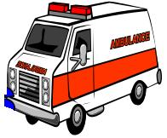

1. The ________________________ is used to carry sick people to the hospital in cases of emergency.

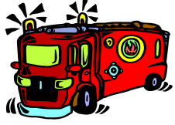

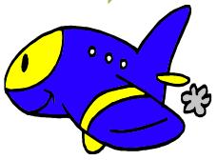2. The ________________________ is used by firemen to travel to places where fires need to be extinguished.

3. Sam is going to the Philippines by ____________________________.

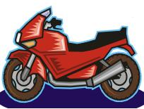

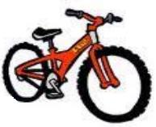4. My father likes to ride his _________________________ on weekends.

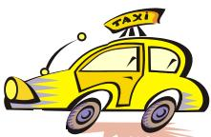5. Jane rides his _______________________ to school.

6. She is now on a _____________________ going home.

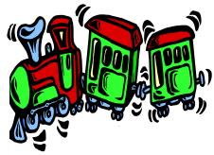

7. We rode on a ___________________________ to the city.

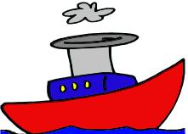

8. The __________________ in the movie Titanic was so big.

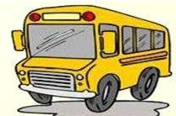

9. We ride the school _____________________ every morning.

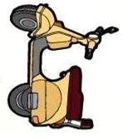

10. I would like to have a _________________________.