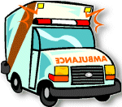
E
A
N
S
O
F
T
R
A
N
S
M
1
2
3
4
5
6
7
8
9
10
11
P
O
R
T
12
13
14
15
16

shuttle helicopter fire truck airplane motorbike bicycle bus

car yacht ambulance jeep ship scooter

taxi canoe train


