LIKES AND DISLIKES PRACTICE
I LIKE……



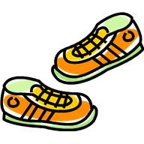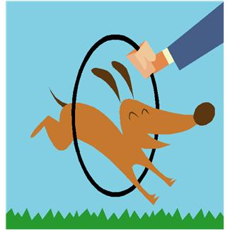


MANDY LIKES……



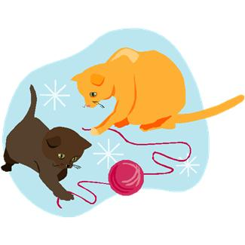


DICK LIKES…...

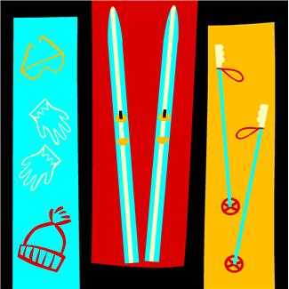
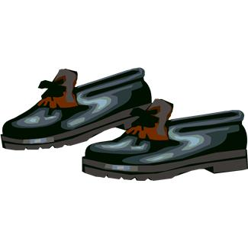

1. Write affirmative or negative sentences according to the pictures. Use like, likes, don’t like, doesn’t like:

1. Dick …………………… skiing, but he ……………………… cycling.
2. Mandy and I ……………………… cycling.
3. …………… Dick ……………… ironing? ………, ………………
4. I ……………… trainers, but Mandy and Dick ………………
5. …………… Mandy and you …………… skiing, Dick? ………, …………………… .
6. I …………… sushi, but Dick ……………….
7. ……………… you ……………… fruit, Mandy? …………, ……………. I …………………… grapes.
8. Dick ………………… housework.
9. ……………… all of you …………… computers? …………, ………………… .
10. Many …………………… tennis.
11. I …………………… grapes or strawberries.
12. Who ……………… cycling? Mandy and I ……………….
13. I ………………… washing up, but Mandy and Dick ………………….
14. …………… Dick ……………… skiing, Mandy? …………, ………………….
2. Say if the sentences are True or False. Correct the False ones.

1. Two people like gardening ………………………………………
2. All of them like hamburgers ……………………………………
3. None of them likes pets ……………………………………………
4. I like chocolate ………………………………………………………
5. Dick likes apples ………………………………………………………
6. We like fruit ……………………………………………………………
7. Dick and I like cycling ………………………………………………
8. They don’t like computers …………………………………………
9. They like sport …………………………………………………………
10. Mandy doesn’t like plants ………………………………………
3. Write I, Mandy or Dick in the blanks:

1. ………………… likes grapes and …………… like apples.
2. ………………… like tennis.
3. ……………… likes cats and ……………… like dogs.
4. ……………… don’t like shoes, ………… like trainers.
5. …………… and ……………… like sushi, but ……………… doesn’t.
6. …………… likes cooking.
7. ……………… and …………… like ironing.
8. ………………… likes chocolates.

