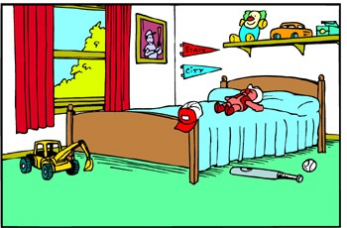

Name:

Ken's Messy Room

Ken’s room was a mess! There were toy trucks on the floor. There were books by the door. There were pants on the bed.

Ken’s dad said, “This room is a pig pen! Clean it now!” He was not happy. Ken got to work.

He made his bed. He put his trucks in the toy box. He put his books away. He folded the pants and put them away.

Ken’s Dad came back. “You did a great job,” he said. Ken and his dad were both happy.

Name:

Ken's Messy Room

1. What was by the door?

2. What did Ken's dad say when he saw the

mess?

3. Where did Ken put his trucks?

a. under the bed b. on a shelf

c. by the door d. in the toy box

4. What did Ken do to the pants?
ANSWER KEY

Ken's Messy Room

1. What was by the door?

books

2. What did Ken's dad say when he saw the mess?

“This room is a pig pen. Clean it up now.”

3. Where did Ken put his trucks? d

a. under the bed b. on a shelf

c. by the door d. in the toy box

4. What did Ken do to the pants?

He folded them and put them away

