**[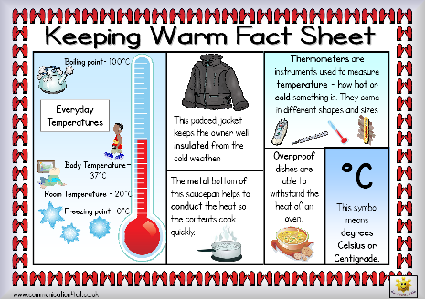](http://www.communication4all.co.uk/Science%202/Keeping%20Warm%20Double%20Sided%20Fact%20Sheet.pdf)**