

**HAVE GOT or HAS GOT**

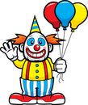Complete the sentences using Have got or Has got

1. The clown __________ three balloons.

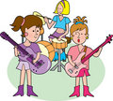

1. The girls __________ a band



1. Ben __________ four presents.

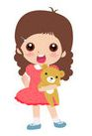

1. Sally __________ a teddy bear

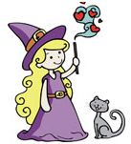

1. The witch __________ a cat.
2. 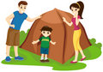Mary, Mike and Jimmy __________ a 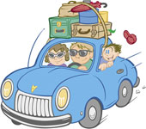tent
3. My family __________ a car

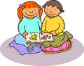

1. Kate and Ben __________ a book

Put the sentences in the negative form.



1. We’ve got a new car.

________________________________________

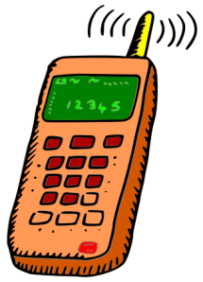

1. You’ve got a mobile in your bag.

_______________________________________



1. Betty has got ten DVDs.

_________________________________________

[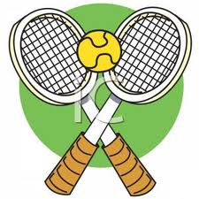](http://www.google.com.pe/imgres?q=tennis+racquets&hl=es-419&biw=1192&bih=515&tbm=isch&tbnid=JzCzRaYy-NzLmM:&imgrefurl=http://www.best-of-web.com/pages/110503-154931-240042.html&docid=hYorEauXuCC8LM&imgurl=http://www.best-of-web.com/_images_300/Tennis_Rackets_Icon_110503-154931-240042.jpg&w=300&h=300&ei=FvKNUK-8Ne6x0QGPpICIAw&zoom=1&iact=hc&vpx=252&vpy=2&dur=1128&hovh=225&hovw=225&tx=117&ty=90&sig=102015285640154665062&page=3&tbnh=147&tbnw=145&start=33&ndsp=20&ved=1t:429,r:14,s:20,i:168)

1. They have got a racquet.

______________________________________

1. I’ve got four tennis racquets in my bag.

_____________________________________.

[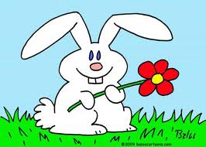](http://www.google.com.pe/imgres?q=they+have+got+a+rabbit+cartoons&hl=es-419&biw=1192&bih=515&tbm=isch&tbnid=wsVqHwAK8V9YjM:&imgrefurl=http://funny-weekend-quotes-and-pictures.funnyfunny12.no-ip.org/&docid=ixNvnos-1lO44M&imgurl=http://fr.toonpool.com/user/997/files/rabbit_flower_403405.jpg&w=500&h=357&ei=kvKNUJzNG6a50AHnzoDoBw&zoom=1&iact=hc&vpx=226&vpy=143&dur=1231&hovh=190&hovw=266&tx=168&ty=115&sig=102015285640154665062&page=1&tbnh=122&tbnw=171&start=0&ndsp=21&ved=1t:429,r:1,s:0,i:66)

1. They have got a rabbit.

_____________________________________________.

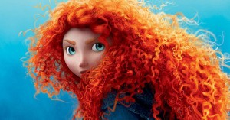

1. She has got curly red hair.

______________________________________.

[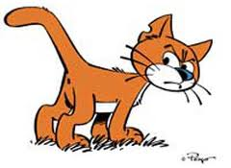](http://www.google.com.pe/imgres?q=cat+cartoons&hl=es-419&biw=1192&bih=515&tbm=isch&tbnid=o4jQkA62n1Hj_M:&imgrefurl=http://www.felinest.com/famous-cartoon-cats/&docid=eMoo9QxQL0pyJM&imgurl=http://www.felinest.com/images/cartoon-cats-1.jpg&w=300&h=219&ei=QPSNUKL3Dsnw0gGq0IHQCg&zoom=1&iact=hc&vpx=128&vpy=195&dur=1461&hovh=175&hovw=240&tx=142&ty=98&sig=102015285640154665062&page=1&tbnh=137&tbnw=200&start=0&ndsp=10&ved=1t:429,r:0,s:0,i:77)

1. Jimmy, Danna and brad have got a brown cat.

___________________________________________.