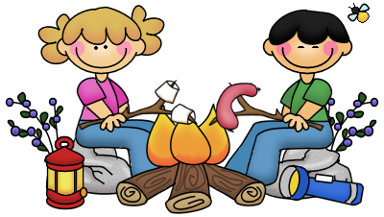
Have / Has Got
1. Fill in the gaps with have or has.
_______ you got a blue pen?
_______ she got a ruler in her pencil case?
_______ Peter got a new bike?
_______ Mark and Sue got nice friends?
_______ Susan got a blue skirt?
_______ they got long hair?
_______ Your mother got a big car?
2. Fill in the gaps with hasn´t or haven´t.
Susan ________ got blue eyes.
Tim and Frank ________ a new computer.
He ________ a big family.
I ________ a new book in my bag.
They ________ short hair.
Julie ________ a younger brother.
Mr. Smith ________ a blue car.
3. Fill in the gaps with the Verb “ Have got”
Tina _________ a brother and two sisters.
They _________ a big house.
My brother and I _________ blue eyes but we _________ (not) long hair.
_________ Mary _________ a new bike? - No, she _________.
_________ they _________ pencils on their pencil case? - Yes, they _________.
Every classroom _________ a computer.
We _________ new book every year.
Make questions with these words. Give short answers. Follow the example.
Your parents / new car/ ✓
Have your parents got a new car? - Yes, they have.

Mary / a bad husband /✗
______________________________________________________________________________

