Task 1. Find and match the biography details to the explorers.
1.
1. He was born in Oporto, Portugal, in 1480. His parents were members of the Portuguese nobility, and he found himself in the service of royalty at an early age. As a young member of Queen Leonora's School of Pages in Lisbon (the Portuguese capital) he was encouraged to learn subjects that would aid him greatly later, such as cartography (mapmaking), astronomy, and celestial navigation (learning how to steer a ship based on the positions of the stars). He joined the Portuguese service to sail with the fleet in 1505. He went to East Africa and later was at the battle of Diu, in which the Portuguese destroyed the Egyptian fleet's dominance in the Arabian Sea. He went twice to Malacca, located in present-day Malaysia, and participated in that port's conquest (the act of conquering) by the Portuguese. It is possible that he also went on a mission to explore the Moluccas (islands in Indonesia, then called the Spice Islands). Indies.
Read more: Ferdinand Magellan Biography - life, parents, school, young, information, born, house, time http://www.notablebiographies.com/Lo-Ma/Magellan-Ferdinand.html#ixzz27xccbYGY

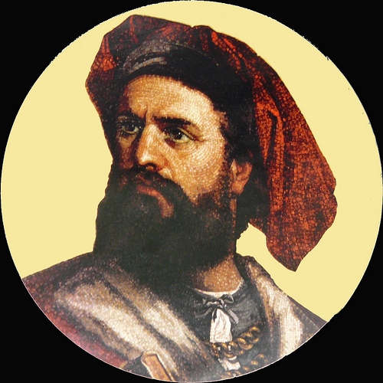

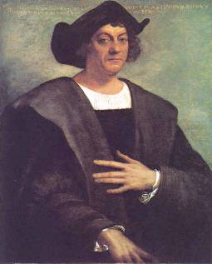
2.
2. He was born in Venice in 1254. Both his father and uncle were leading merchants who had nearly met the Mogul emperor, Kublai Khan. When he was17, he set off with them on an adventure that would last over 20 years. His father took three letters to give to the emperor. From Palestine they passed through Turkey into Iran. In Afghanistan they stopped for a year, probably coming over malaria. They continued overland through the Great Silk Road and across the Gobi desert. Lately , in 1275 they reached the summer capital where they met the emperor.. The young man was sent on missions to report back on his master’s vast empire. The travelers wanted to return home, the opportunity only came 17 years later. They were given permission to leave in case they accompanied a Mogul princess who was to be married in Persia.

5.

3.
3. He was a Portuguese explorer, one of the most successful in the Age of Discovery and the commander of the first ships to sail directly from Europe to India.He is one of the most famous and celebrated explorers from the Discovery Ages, being the first European to reach India through sea. This discovery was very impactful and paved the way for the Portuguese to establish a long lasting colonial empire in Asia. The route meant that the Portuguese wouldn't need to cross the highly disputed Mediterranean nor the dangerous Arabia and that the whole voyage would be made by sea. For his contributions he was named in 1524 as the Governor of India, under the title of Viceroy, and given the newly created County of Vidigueira in 1519.

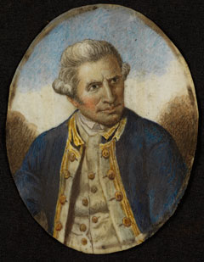

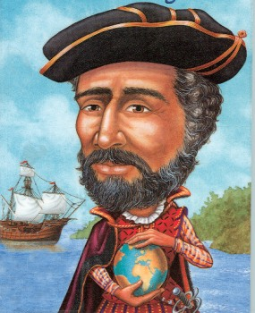
4.
4. He dreamed of sailing across the ocean. He read the stories of Marco Polo. He too wanted to visit Asia. He hoped to find gold, spices, and other treasures. In 1492, his dream came true. He sailed from Spain with 90 men and three ships. The names of his ships were the Nina, the Pinta, and the Santa Maria.
He and his men left Spain on August 3, 1492. He thought he would
reach Asia in five weeks. But the men sailed for more than two months and did not see land. Many wanted to give up and go home. Then, on October 12, 1492, a sailor saw something. “Land! Land!” he cried.
He and his men landed on an island. They named the island San Salvador.

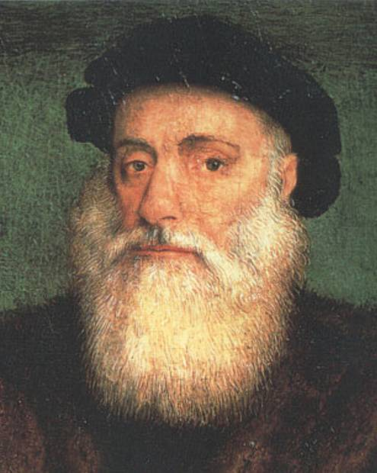

5. He was born in 1728 in Marton, England. His father was a Scottish migrant farm worker who allowed him to apprentice on coal carrying boats at the age of eighteen. While working in the North Sea, He spent his free time learning math and navigation. This led to his appointment as mate. Searching for something more adventurous, in 1755 he volunteered for the British Royal Navy and took part in the Seven Years War and was an instrumental part of the surveying of the St. Lawrence River, which helped in the capture of Quebec from the French.
Following the war, His skill at navigation and interest in astronomy made him the perfect candidate to lead an expedition planned by the Royal Society and Royal Navy to Tahiti to observe the infrequent passage of Venus across the face of the sun.

Key:
1-2
2-4
3-5
4-1
5-3

