**candy apples melon tomatoes sugar** **juice** **grapes**  **cookies bananas corn eggs chicken** **milk**  **strawberries** **cake oranges carrots bread pizza**  **tea** **celery** **chocolate peaches potatoes butter sandwiches** **water** **lettuce**

**What  Foods  Do  You  Like?**

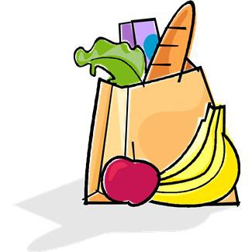

**1. I  like  __________________________.**

**2. I  don’t  like  __________________________.**

**3. I  like  __________________________.**

**4. I  don’t  like  __________________________.**

**Eat:**

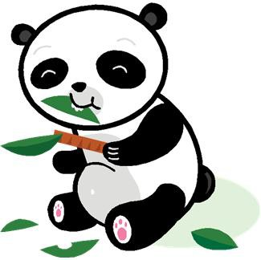

**1. I  like  to  eat  __________________________.**

**2. I  don’t  like  to  eat  __________________________.**

**3. I  like  to  eat  __________________________.**

**4. I  don’t  like  to  eat  __________________________.**

**Drink:**

**1. I  like  to  drink  __________________________.**

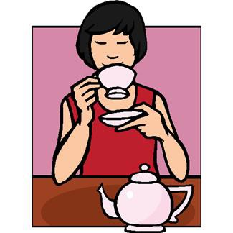

**2. I  don’t  like  to  drink  __________________________.**

**3. I  like  to  drink  __________________________.**

**4. I  don’t  like  to  drink  __________________________.**

**Foods:**

cake pizza chicken sandwiches butter apples oranges carrots peaches eggs

melon potatoes bread celery chocolate cherries bananas grapes corn lettuce

tomatoes mushrooms cookies onions

candy peas

**Drinks:**

water milk juice tea

**Fill  in  the  blanks  with  foods  and  drinks  that  you  like  and  don’t  like.**

1. I like to eat and .

2. I don’t like to eat and .

3. I like to drink and .

4. I don’t like to drink .

5. I to eat eggs and I to drink tea.

6. My favorite food is and my favorite drink is

.