1. LOOK AND COMPLETE WITH THE CORRECT SENSE

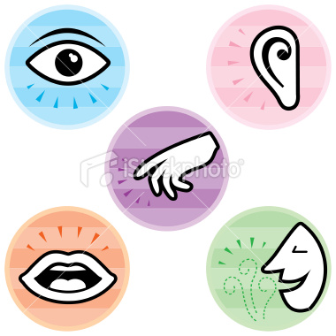

1. COMPLETE

* We see with our ______________
* We smell with our ______________
* We listen with our _______________
* We feel with our _______________
* We taste with our _______________

1. COMPLETE WITH THE CORRECT SENSE

* When I see a film I use this sense. _______________
* When I touch my dog I use this sense. ________________
* When I smell my mom’s perfume I use this sense. _________________
* When I listen to music I use this sense. ___________________
* When I taste my favorite food I use this sense. ___________________

1. COMPLETE

* I ______________ with my eyes
* I ______________ with my nose
* I ______________ with my fingers
* I ______________ with my tongue
* I ______________ with my ears