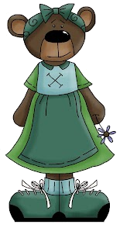
Form
If clause + main clause
If+ present simple + will + base verb

Uses | Example
Promises | If you help me, I’ll give you a present.
Threats/ warnings | I’ll tell the police if you do it again.
Logical consequences | If you don’t take the umbrella, you’ll get wet.
Offers | If you like, I’ll help you.
Making a deal | If you clean the bathroom, I’ll clean the kitchen.

A. Write the correct form of the verbs in brackets.

- If it is hot this afternoon, we ______________ (go) to the beach.

- If it is cold this afternoon, we ______________ (not go) to the beach.
- Peter ______________(get) into trouble if he steals that cell phone!
- You ______________(not pass) if you don’t study harder!
- I ______________(make ) dinner if you like.
- If it ______________(not be) too expensive, we’ll buy it.
- I ______________(give) you $5 if you ______________ (wash) my car.
- I ______________(phone) you if I ______________(have) any news.
- If we ______________(not help) them, they ______________(not finish the work on time.
- I ______________(buy) a new laptop computer if I ______________(save) enough money.
- He ______________(not go) to school tomorrow if he ______________(not feel) better.
- If they (not hurry), they ______________(be) late.
- If it ______________(snow), we ______________ (build) a snowman.
- If you ______________(eat) everything now, you ______________(not have) anything to eat at lunchtime!
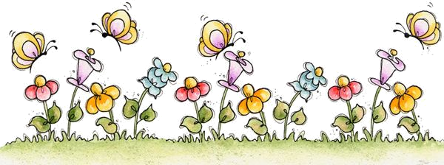
- If you ______________(not turn down) the music, you ______________ (wake up) the baby!
Answer key

- ‘ll go
- won’t go
- will get
- won’t pass
- ´ll make
- isn’t
- ´ll give; wash
- ‘ll phone; have
- don’t help; won´t finish
- ‘ll buy; save
- won’t go; doesn’t feel
- don’t hurry; will be
- snows; ‘ll build
- eat; won’t have
- don’t turn down; ‘ll wake up

