 | 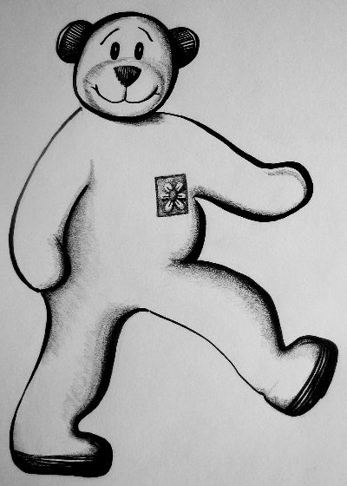  Start  Start |  |  |  | rot |  |  |  | blau
 | grün |  |  |  | gelb |  |  |  | schwarz
 | weiß |  |  |  | braun |  |  |  | orange
 | rosa |  |  |  | lila |  |  |  | bunt | 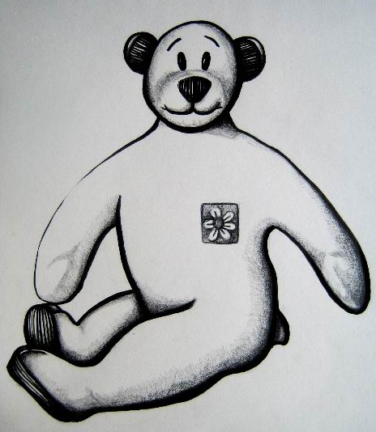  Ende

