DIVISION

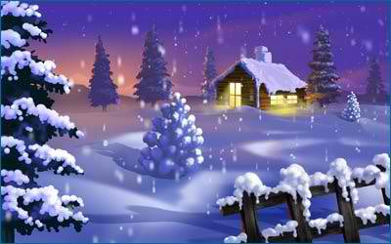

- Share 56 equally among 7. _________________________________
- Group 60 in sixes.________________________________________
- Divide 81 equally among 9._________________________________
- Zero divided by 5. ________________________________________
- Divide 27 by 9. __________________________________________
- __ ÷8 = 5 __÷ 10 = 5 __ ÷ 4 =5 __÷5 = 5
- 6000 ÷10 = ____ 5000 ÷ 100 = ____ ____ ÷ 100 = 300
- Half of 90 is __________________________
- Double 46 is _________________________
- These cards are shared equally among four shelves. How many cards go on each shelf and how many are left over?
- 65 cards b) 50 cards c) 85 cards
________________________________________________
________________________________________________
________________________________________________

