DIVISION
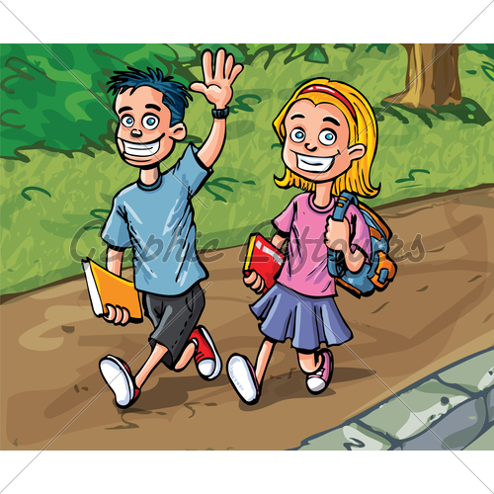

- 32 ÷ 4 = ___ 27 ÷ 3 =___ 16 ÷ 4 = ___ 0 ÷ 2 =___

__÷ 2 = 9 __ ÷ 5 = 4 15 ÷ __= 3 70 ÷ __= 10

- Divide 100 by 10._____________________________________

- Share 14 equally among 7? ___________________________________

- How many groups of 6 are in 42? _______________________________

- 81 divided by 9? ____________________________________________

- Mark spent £56 on books. The books cost £8 each. How many books did he buy? _____________________________________________________

- Each row has 9 seats. How many rows are needed for 81 children? _________________________________________________________

- The cart carries 8 children on each trip. How many trips are needed for:

- 24 children _________________________________________
- 64 children __________________________________________
- 80 children __________________________________________
- 56 children __________________________________________

