**Days & Actions**

My name is: …………………………………………………………………………………………………

Find the days in the puzzle and write them in order on the lines.

**1**

|  |  |  |  |  |  |  |  |  |  |
| --- | --- | --- | --- | --- | --- | --- | --- | --- | --- |
| A | J | O | S | E | R | T | Y | U | D |
| M | O | N | D | A | Y | E | R | U | F |
| W | Q | E | R | T | T | W | I | Y | T |
| S | A | S | T | F | G | E | R | T | Y |
| A | O | T | U | E | S | D | A | Y | H |
| T | I | H | D | E | R | N | E | Y | J |
| U | U | U | W | D | F | E | F | T | K |
| R | H | R | T | E | R | S | D | V | L |
| D | I | S | F | R | I | D | A | Y | O |
| A | O | D | T | H | J | A | N | M | P |
| Y | P | A | R | Ñ | K | L | F | G | J |
| U | T | Y | F | S | U | N | D | A | Y |

1. _________________________________

2. _________________________________

3. _________________________________

4. _________________________________

5. _________________________________

6. _________________________________

7. _________________________________

Match the picture with the action.

**2**







Go to… Take Say Get up

Wear Check Stand on Do

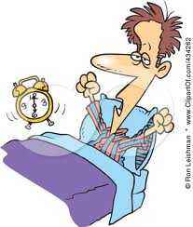

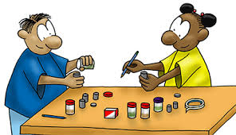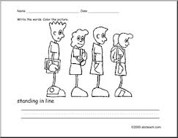

Complete the chart.

**3**

|  |  |
| --- | --- |
| **AFFIRMATIVE** | **NEGATIVE** |
| I take the bus |  |
|  | They don’t stand on line |
| She does a Project |  |
|  | She doesn’t wear a school uniform |
| He gets up |  |
|  | I don’t say hello |
| She checks the homework |  |
|  | You don’t go to the computer room |

**4**

Put the actions according to the sentences below.

|  |  |  |  |  |  |  |
| --- | --- | --- | --- | --- | --- | --- |
| Monday | Tuesday | Wednesday | Thursday | Friday | Saturday | Sunday |
|  |  |  |  |  |  |  |
|  |  |  |  |  |  |  |

1. I get up at 7 o’clock **everyday**
2. On Monday I **say hello** at 8 o’clock
3. On Wednesday I **take the bus** at 7.45 am
4. On Tuesday I **go to the computer room** at 11.30 am
5. On Friday I **check my Math Homework** at 12 o’clock
6. On Thursday I **do a project** at 9.45 am
7. On Saturday I **don’t wear a school uniform**
8. On Sunday I **don’t get up** at 7 o´clock