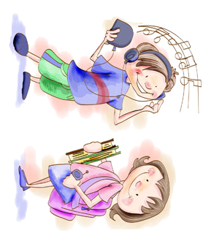
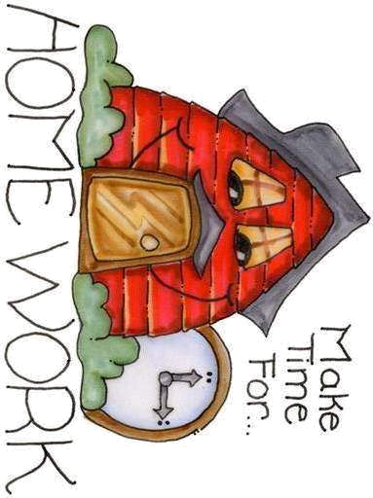
• We use as + adjective + as in affirmative sentences to say that things are equal.
Example : Mary runs as fast as Mary.
• In a negative sentences, we can use
as + adjective + as or so + adjective + as to say things are not equal.
Example: She cannot go as far as / so far as the others.
AS … AS / SO ...AS
… + ER THAN / MORE … THAN
A) Short adjectives (1 or 2 syllables) + er + than
Example: Mary is taller than Ann.

B) More + long adjective + than
Example: She is more intelligent than Susan.
• Adjectives ending in -y change the -y to -i + er
Example: Mark is heavier than John.
• When the adjective ends in a vowel + consonant, the consonant at the end is doubled.
Example: big → bigger
SOME ADJECTIVES HAVE IRREGULAR FORMS
good → better bad → worse
COMPARISON OF ADJECTIVES.
GRAMMAR
STUDY
A ) Write the comparative form of the given adjectives:

1. Young
2. rich
3. old
4. long
5. big
6. happy
7. good
8. beautiful
9. expensive
10. ugly

B) Complete the sentences. Use the comparative of the adjectives.

1. In summer it is _____________ (hot) in any other season.
2. Children are _______________ (busy) during the term time.
3. Sometimes the weather is __________ (bad) in summer than in the winter.
4. In winter it is ____________ (freeze) than in Autumn.
5. In autumn it is _________ (rainy) than in summer.
6. In Spring it is _____________ (windy) than in winter.
7. Winter _____________ (cold) than any other season.
C) Use as… as or so … as to build sentences with the given information.

EX. Mr. Smith is 80 years old. Mr Sims is 75 years old.
Mr. Sims is not as old as Mr. Smith.

• Mark is 1m70. Judy is 1m30.
• __________________________

• This jumper costs $40. The shorts costs $ 30.
• __________________________

• Mary weights 50 kilos. Ann weights 60 kilos.
• __________________________

D) Ten of these sentences are wrong. Find them and write them correctly.

• My sister is taller as yours.
• She is more diligent than my brother.
• My English dictionary is heavier and more thick than theirs.
• A Ferrari is more expensive than a Rover.
• Who’s more big? John or Carl?
• What's more good? Water or tea?
• I think Jane is older than Kate. Don't you think so?
• Well, I think they are the same age.
• Those jeans are as expensiver as these ones.
• Peter’s rucksack is so smaller as mine.
• Sit down here! This sofa is than more comfortable that chair.
• Mary’s house is very nicer.
• This exercise is easier than the other one.

