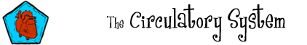

Find the circulatory system words below in the grid to the left.

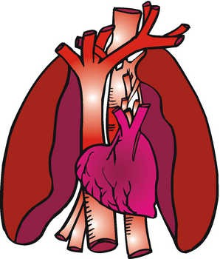
Across  3. The place where nutrients enter the blood.  7. The pump in the circulatory system.  8. A small vessel that connects veins and arteries.  10. The circulatory system ___________ nutrients, gases, liquids, and heat around the body.  11. The circulatory system transports this, which helps regulate temperature.  12. The liquid in the circulatory system.  13. The place where oxygen enters the blood and carbon dioxide leaves the blood.  14. A vessel that moves blood to the heart.  15. A gas that is transported in arteries from the lungs to the rest of the body via the heart. | Down  1. The heart ___________ blood.  2. The heart, blood, and vessels.  4. Blood in arteries is ____________ red because it is rich in oxygen.  5. The largest artery in the body.  6. A waste gas that is transported in veins from the body to the lungs via the heart.  9. A vessel that moves blood away from the heart.
© 2006 www.bogglesworldesl.com

