ALL AROUND MY TOWN: PLACES

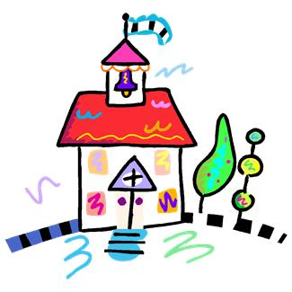 | 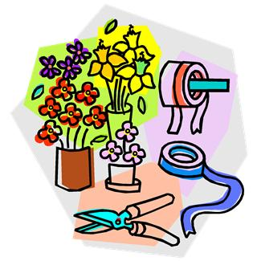 | 1. Say where these people want to go.  A. I’m broke and I need some money.  B. We’re having dinner out to celebrate our wedding anniversary on Saturday evening.  C. Mary usually borrows books after school.  D. The sweaters are on sales now.  E. Let’s buy a bunch of roses for mum.  F. I’ve got a terrible headache. I need some aspirins.  G. Get some bread and some cakes for dinner, please.  H. We have to buy a teddy bear for baby Jim.  I. Parents usually take their children there after school.  J. My grandma needs a pair of new glasses.  K. Tom is giving Jane an engagement ring.  L. Let’s get some for Peter. He really likes sweets.  M. Tina exercises there every day.  N. My friends usually see good films there.  O. Mum is having a haircut on Monday morning.  P. Can you get me a newspaper, please?  Q. We need some salmon for lunch.  R. Paul Auster has just published a new novel; let’s buy it tomorrow.  S. Children go there every day even if they don’t like it.  T. Where can I get some apples and some tomatoes?  U. My dad’s suit needs cleaning.  V. Do they sell fresh sausages?  3. Match the name of the places under the correct picture. | 2. Write the names under the correct picture.  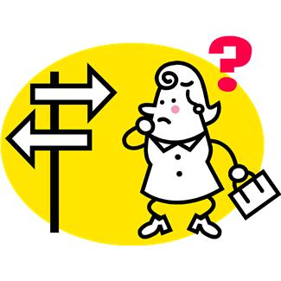  TOY SHOP  JEWELLERY  BANK  FLORIST’S  PARK  BOOKSHOP  NEWSAGENT’S  SCHOOL  CINEMA  SWEET SHOP  BAKERY  DRY CLEANER’S  GYM  FISHMONGER’S  LIBRARY  RESTAURANT  GREENGROCER’S  CHEMIST’S  HAIRDRESSER’S  OPTICIAN’S  BUTCHER’S  CLOTHES SHOP  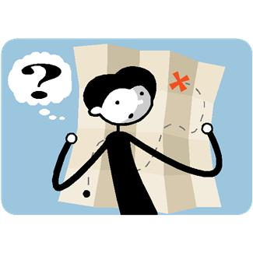
  1 …… | 2 …… | 3 …… | 4 …… | 5 ……
  6 …… | 7…… | 8 …… | 9 …… | 10 ……
  11 …… | 12 …… | 13…… | 14 …… | 15……
  16 …… | 17 …… | 18…… | 19 …… | 20 ……
1. | 2.
 | 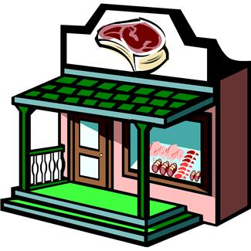
3. | 4.
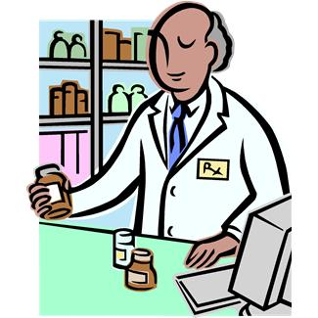 | 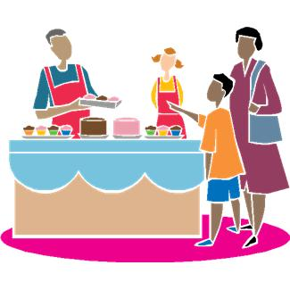
5. | 6.
 | 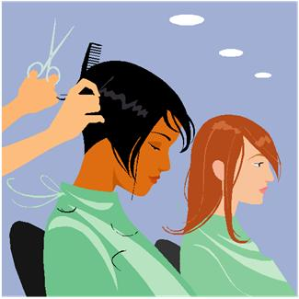
7. | 8.
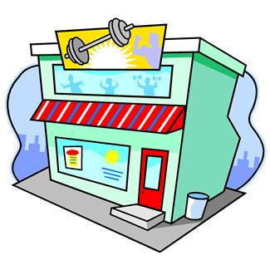 | 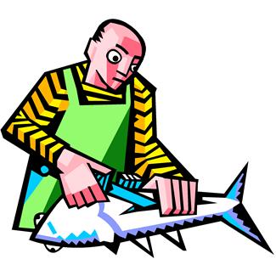
9. | 10.
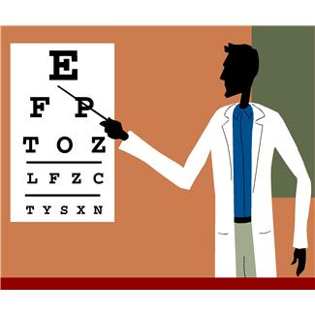 | 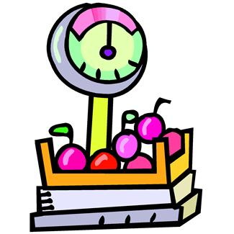
11. | 12.
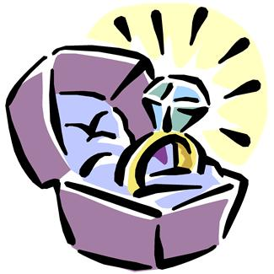 | 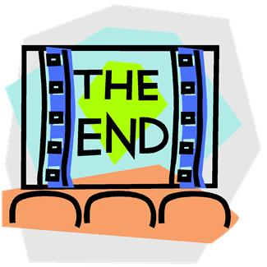
13. | 14.
 | 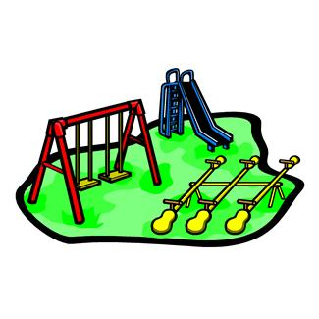
15. | 16.
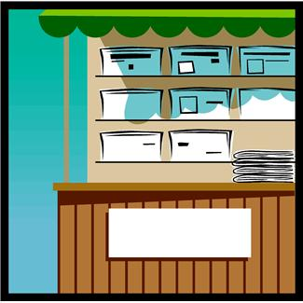 | 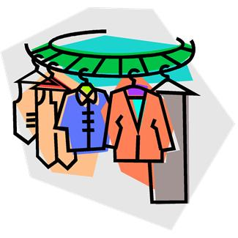
17. | 18.
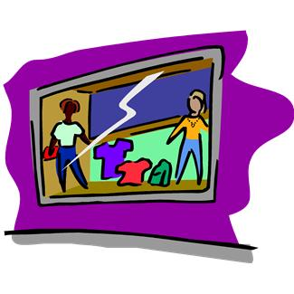 | 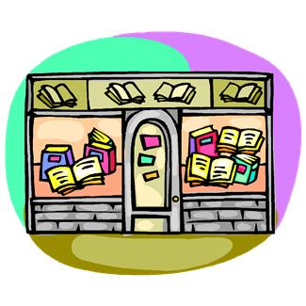
19. | 20.
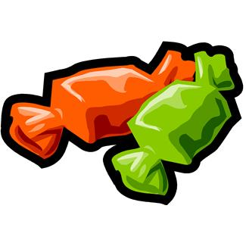 | 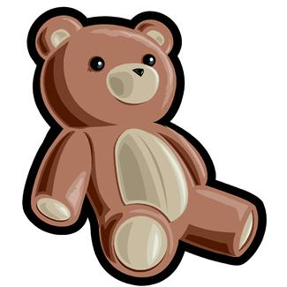
21. | 22.

KEY

1)

1. SCHOOL
2. FLORIST’S
3. LIBRARY
4. BUTCHER’S
5. CHEMIST’S
6. BAKERY
7. BANK
8. HAIRDRESSER’S
9. GYM
10. FISHMONGER’S
11. OPTICIAN’S
12. GREENGROCER’S
13. JEWELLERY
14. CINEMA
15. RESTAURANT
16. PARK
17. NEWSAGENT’S
18. DRY CLEANER’S
19. CLOTHES SHOP
20. BOOKSHOP
21. SWEET SHOP
22. TOY SHOP

3)
.
1 S | 2 F | 3 C | 4 V | 5 F
6 G | 7 A | 8 O | 9 M | 10 Q
11 J | 12 T | 13 K | 14 N | 15 B
16 I  21 L | 17 P  22 H | 18 U | 19 D | 20 R

