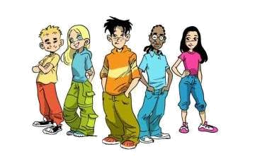
ADJECTIVE
SUPERIORITY
One syllabe

Cheap
small

(the) cheapest
(the) smallest
Two syllables ending in Y:
Pretty
Tasty

(the) prettiest
(the) tastiest
Two or more syllables:
Boring
Expensive

(the) most boring
(the) most expensive
ADJECTIVES
1. Use the adjectives in brackets in the comparative form and add than if necessary:
A) The clothes in this shop are _________________ (expensive)
B) Her Job is _________________ (funny) as I thought.
C) This ice-cream is even _________________ (delicious) that one.
D) Her marks _________________ (good) mine.
E) This music is horrible. In fact, I´ve never heard _________________ (bad).
F) Portugal is _________________ (small) than Spain.
2. Use the adjectives in brackets in the superlative form:
A) Can you tell me _________________ (short) way to the park?
B) His _________________ (big) dream is to have a Ferrari.
C) Who is _________________ (intelligent) student in class?
D) She is _________________ (kind) person I know.
E) France is not_________________ (big) country in Europe.
F) Today is _________________ (hot) day of the year.
3. Choose the best form:
A) They say Cristiano Ronaldo is better / the best footballer in the world.
B) Dolphins are more intelligent / the most intelligent than whales.
C) Chinese is more difficult / most difficult than Portuguese.
D) He is the funnier / the funniest person I´ve ever met.
E) Mary is fatter than / the fattest she was last month.
F) They are better / the best singer than us.
G) Mr. Smith is better / the best English teacher at school.
H) The Lion is more dangerous / most dangerous than cats.
ADJECTIVE
SUPERIORITY
EQUALITY
INFERIORITY
One syllable:
Cheap
Small

Cheaper (than)
Smaller (than)

As cheap as
As small as

Not so/ as cheap as
Not so / as small as
Two syllables, ending in Y:
pretty

Prettier (than)

As pretty as

Not so / as pretty as
Two or more syllabes
expensive

More expensive (than)

As expensive as
Not / so / as expensive as
ADJECTIVE
COMPARATIVE
SUPERLATIVE
GOOD
Better (than)
(the) best
MUCH / MANY
More (than)
(the) most
LITTLE
Less (than)
(the) least
BAD
Worse (than)
(the) worst

