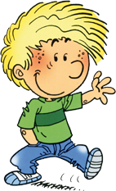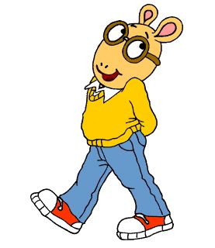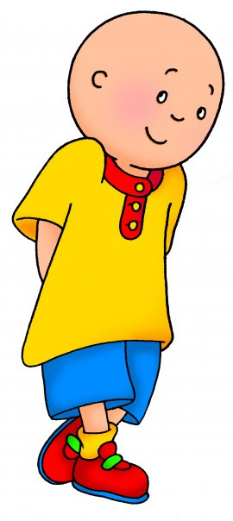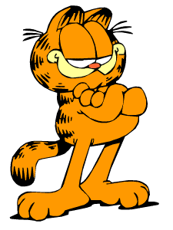
PEPEE
CEDRIC
ARTHUR
CAILLOU
GARFIELD

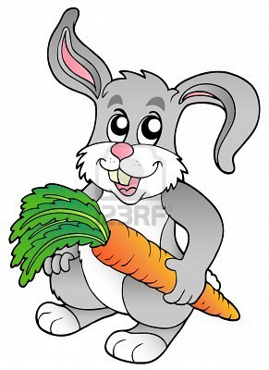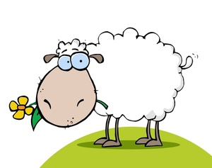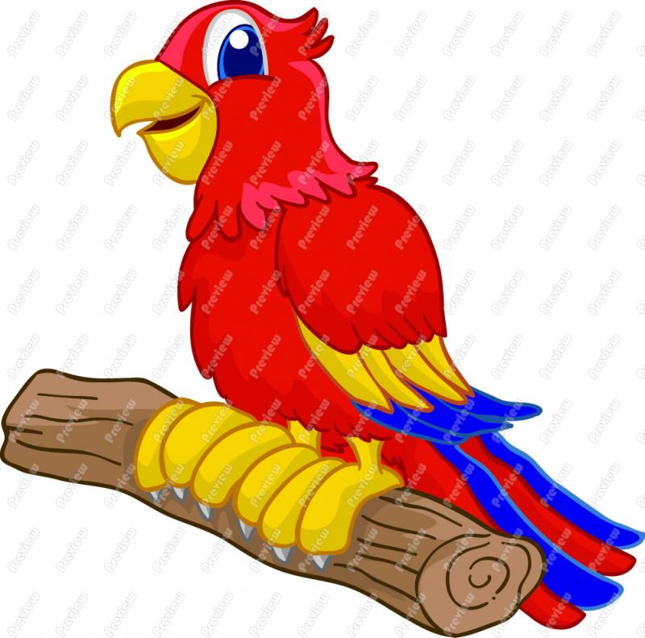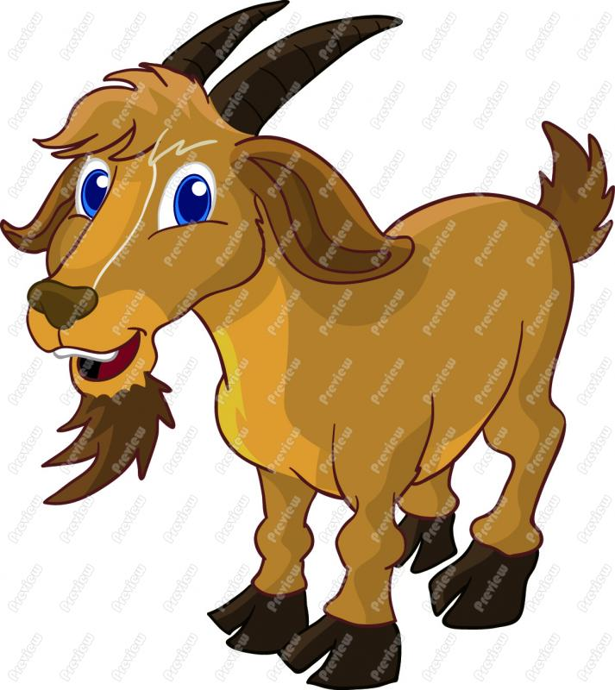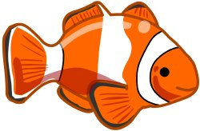
LOOK AT THE PICTURES AND COMPLETE THE SENTENCES.
- Pepee ……………………………………………………………….
- Cedric ……………………………………………………………….
- Arthur ………………………………………………………………...
- Caillou ………………………………………………………………
- Garfield………………………………………………………………

Fill the gaps with “have/has”
- They ………… got three books.
- She ………… got thirteen skirts.
- We …………. got two hands.
- It ………… got four legs.
- I …………….. ten fingers.

Answer the questions according to the pictures.
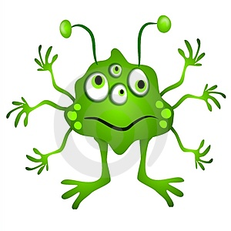
- How many hands has it got?

- How many eyes has it got?

- How many legs has it got?

- How many ears has it got?

- How many arms has it got?

- How many mouth has it got?

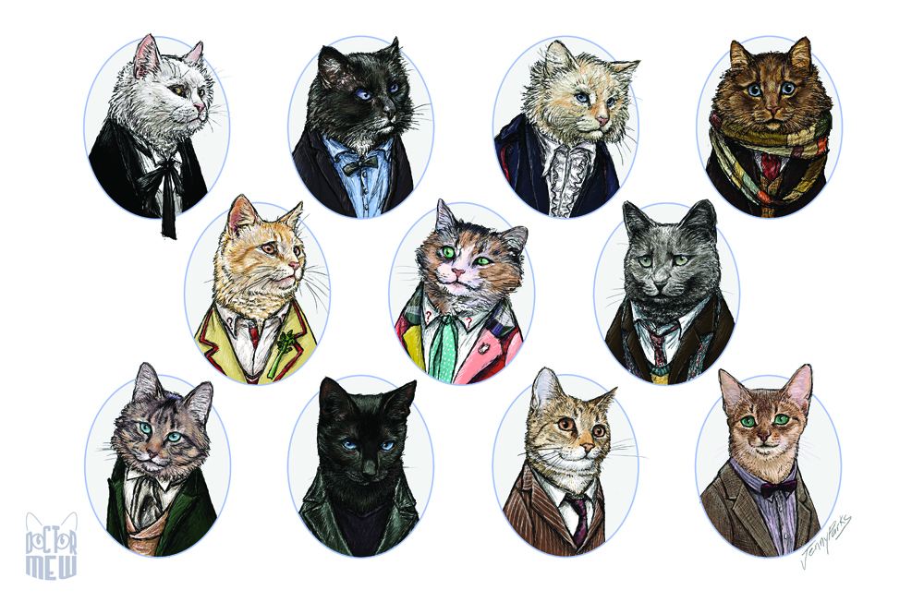
- How many dogs has your father got?

- How many cats have they got?

- How many animals has he got?

- How many cows has she got?
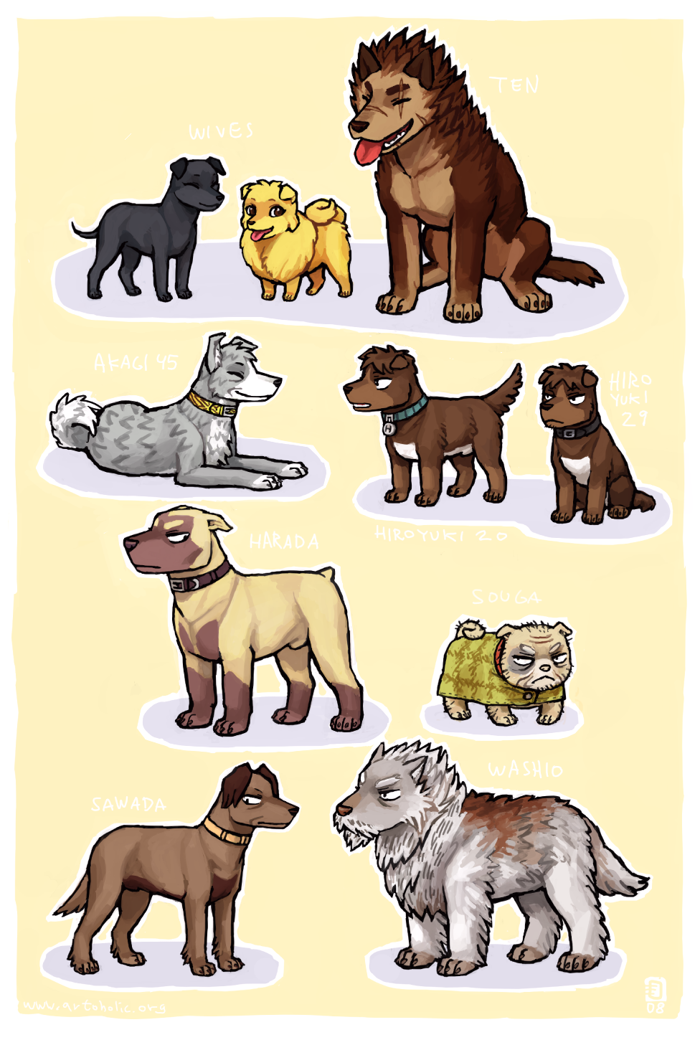
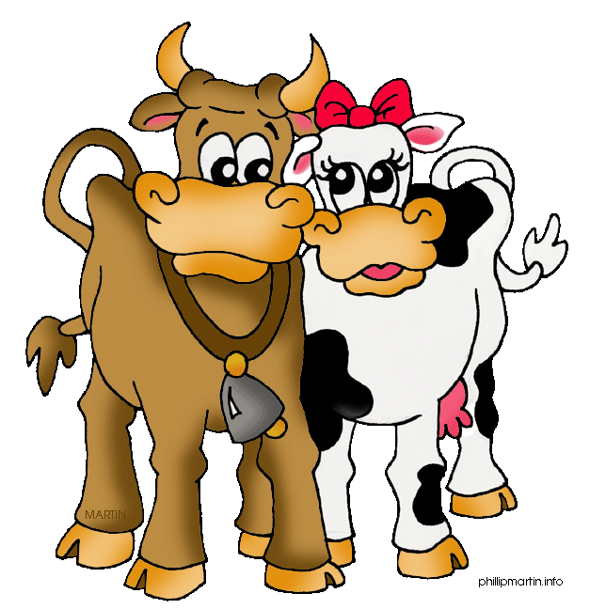
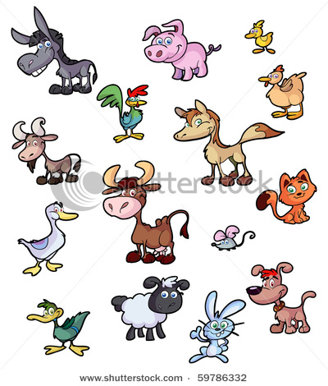

Fill the gaps with “ he, she, it, they”

1)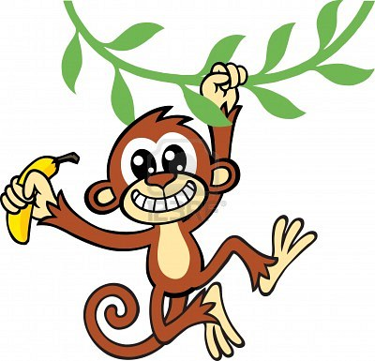……………. 2)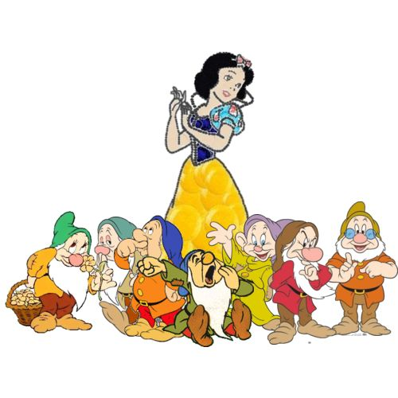……………………
3)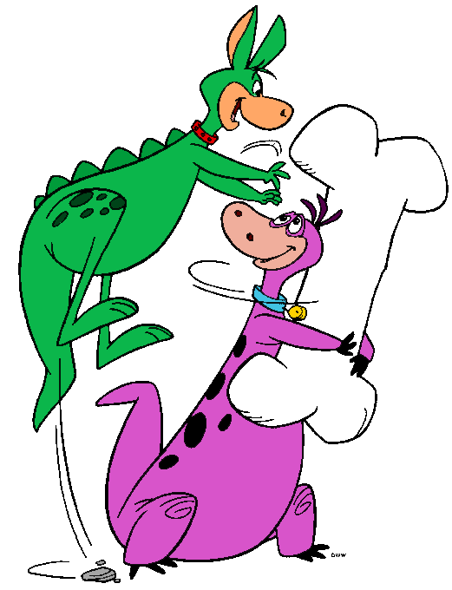…………….. 4)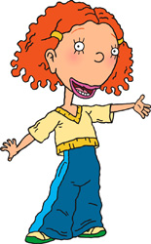……………………
5)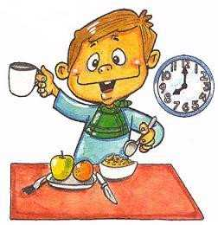…………….. 6)……………………
7)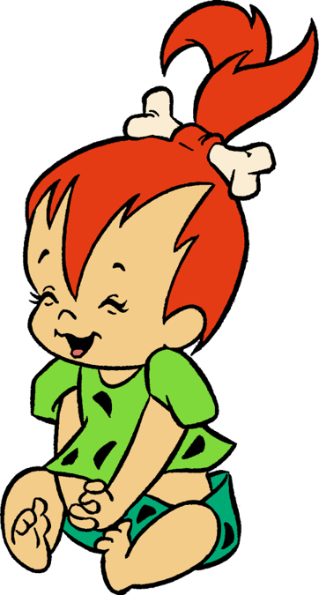…………………. 8)

