Practicing test , I2, Environmental Management

Name _________________________________________________ total mark _____________________________

1. (a) Modern human society relies on the generation of electricity. This can be achieved using

energy from a variety of sources such as:

coal solar gas wind wave nuclear

geothermal hydro-electric biomass oil

Sustainable energy is the provision of energy that meets the needs of the present

without affecting the ability of future generations to meet their needs.

(i) Place the energy sources in the list above under the correct heading in the table

below.

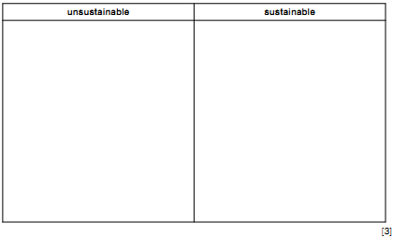

(ii) The length of time for which the unsustainable sources of energy can be exploited could be increased.

Suggest ways in which this could be achieved.

...................................................................................................................................................................................................................................................................................................................................................................................... ............................................................................................................................................................................................................................................................................................................................................................................. [3]

(b) The table below shows the average costs of generating electricity at power stations using gas, oil and coal and nuclear power stations in a selection of developing countries

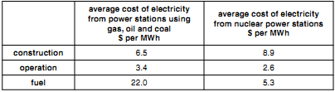

Taking into account these costs, and other factors, state what arguments there might be for and against A a power station using coal, oil or gas and B a nuclear power station.

A ..................................................................................................................................... ..........................................................................................................................................

..........................................................................................................................................

..........................................................................................................................................

B ......................................................................................................................................

..........................................................................................................................................

..........................................................................................................................................

...................................................................................................................................... [4]

[Total: 10

1. (a) Look at the map of the Pacific Ocean showing the location of destructive plate boundaries.

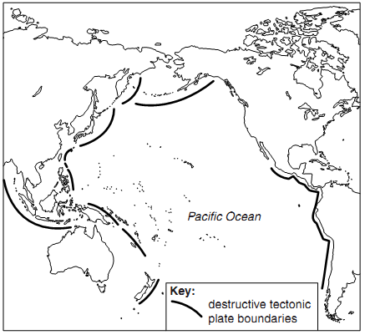

(i) Describe the distribution of destructive plate boundaries in the Pacific Ocean.

..................................................................................................................................

..................................................................................................................................

.............................................................................................................................. [2]

(ii) State what is happening to the plates at destructive plate boundaries.

..................................................................................................................................

..................................................................................................................................

..................................................................................................................................

..................................................................................................................................

.............................................................................................................................. [3

(b) Look at the map of the Pacific Ocean showing the location of active volcanoes.

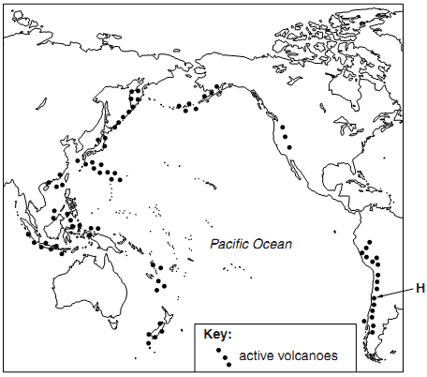

(i) Suggest why the distribution of active volcanoes in the Pacific Ocean is known as

‘The Pacific Ring of Fire’.

..................................................................................................................................

..................................................................................................................................

..................................................................................................................................

.............................................................................................................................. [2]

(ii) Explain how volcanoes are formed along destructive plate boundaries.

..................................................................................................................................

..................................................................................................................................

..................................................................................................................................

..................................................................................................................................

..................................................................................................................................

.............................................................................................................................. [3]

(c) Read the information about a volcanic eruption in Chile in June 2011 (marked H on the map of active volcanoes)

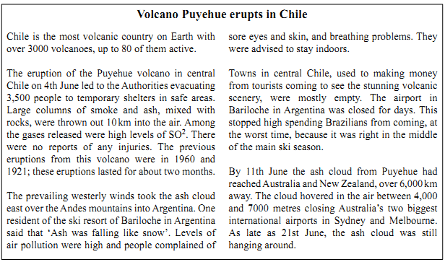

(i) Name all four emissions from the Puyehue volcano during its June 2011 eruption.

1. .............................................................. 2. ............................................................

3. .............................................................. 4. ............................................................

[1]

(ii) Despite this being a major volcanic eruption, no one was killed or even injured.Suggest three reasons for this.

..................................................................................................................................

..................................................................................................................................

..................................................................................................................................

..................................................................................................................................

..................................................................................................................................

.............................................................................................................................. [3]

(iii) The economic effects of Puyehue’s eruption were felt not only in Chile and neighbouring Argentina, but also thousands of kilometres away in Australia. Why were the effects from this volcanic eruption international as well as national?

..................................................................................................................................

..................................................................................................................................

..................................................................................................................................

.............................................................................................................................. [2]

(iv) Were these economic effects greater for the other countries than for Chile? Explain your views on this.

..................................................................................................................................

..................................................................................................................................

.................................................................................................................................. [3]

(d) Land close to and around the craters of active volcanoes is often barren wasteland, places where nothing will grow. One reason is the very acid ground due to frequent releases of toxic volcanic gases and liquids.

1. The pH scale is shown below. Put a tick (✓) in one of the boxes to suggest the pH of a soil found in areas next to volcanic craters.

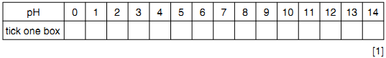

(ii) State and explain another reason why areas on the higher slopes of active volcanoes cannot usually be used for farming.

..................................................................................................................................

..................................................................................................................................

.............................................................................................................................. [2]

(iii) In areas further away from the crater, volcanic soils are some of the world’s best soils for growing crops. Many of them have the texture of a loam soil;

33% sand: 33% clay: 34% silt

Complete the pie graph and key to show these characteristics of a loam soil.

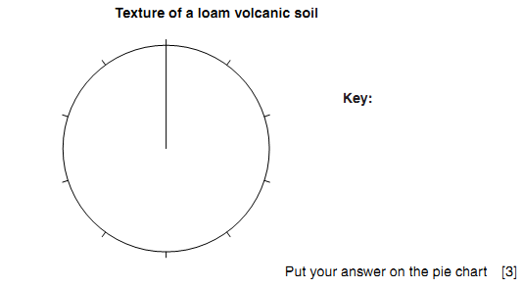

(iv) The pH scale is shown below. Put a tick (✓) in one of the boxes to suggest the pH

of a volcanic soil with a loam texture.

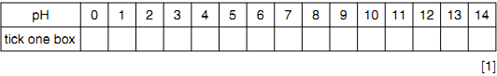

(v) Explain why this soil texture is good for crop growing.

..................................................................................................................................

..................................................................................................................................

..................................................................................................................................

..................................................................................................................................

..................................................................................................................................

.............................................................................................................................. [3]

1. Energy for use by human communities comes from either renewable or non-renewable

sources.

(a) The major non-renewable energy resources are fossil fuels.

(i) Name the three main fossil fuels ................................................................................................................................................................................................................................................................................................................. [2]

(ii) Explain why these are called fossil fuels .............................................................................................................................................................................................................................................................................................................................(1)

1. (a) Look at the pie chart showing average percentages for the composition of soil.

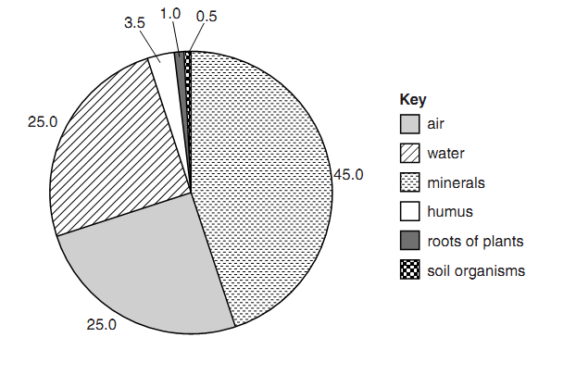

What percentage of this soil consists of organic material?

Show your working and explain your answer.

percentage of organic matter .................................................. %

explanation ...............................................................................................................

..................................................................................................................................

..................................................................................................................................

.............................................................................................................................. [2

1. (i) Water is essential for life on Earth. Why?

..................................................................................................................................

..................................................................................................................................

..................................................................................................................................

..............................................................................................................................[2]

(ii) Look at the diagram which shows part of the water cycle.



Name the water cycle processes at **A**, **B** and **C**.

**A** ……………………………………… **B** ………………………………………

**C** ……………………………………… [3]

**(iii)** Rock layers **P** and **Q** have different effects on water movement underground. How

and why are they different?

.................................................................................................................................

.................................................................................................................................

.............................................................................................................................. [2]

**(b)** Look at the world map of water availability. It shows

• areas already at risk from severe water shortages

• countries expected to be at risk from severe water shortages by 2025, likely to be

bad enough to restrict water use.





Describe the distribution of areas and countries with water shortages (already and

expected by 2025).

.........................................................................................................................................

.........................................................................................................................................

.........................................................................................................................................

.........................................................................................................................................

.........................................................................................................................................

.........................................................................................................................................

..................................................................................................................................... [4]