**C E L L D I V I S I O N**

1. Define the following:

|  |  |
| --- | --- |
| Cell cycle | *All stages in the life cycle of a cell.* (1) |
| Interphase |  |
| Mitosis |  |
| Cytokinesis |  |
| Apoptosis |  |
| Necrosis |  |
| Diploid |  |
| Haploid |  |

1. Draw and label a pie chart to show the relative amount of time spent in each phase of the cell cycle, including the stages of interphase and mitosis, as well as cytokinesis.
2. Outline the stages of interphase.

|  |  |  |
| --- | --- | --- |
| **Stage** | **Events** | List three metabolic reactions that occur during interphase |
|  |  |  |
|  |  |  |
|  |  |  |

1. 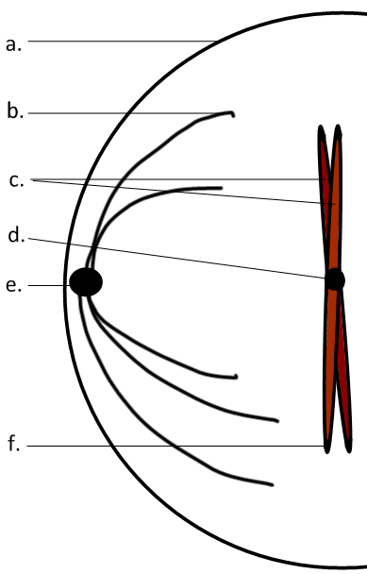Label the diagram.

|  |  |
| --- | --- |
| a | Plasma membrane |
| b |  |
| c |  |
| d |  |
| e |  |
| f | telomeres |

1. Distinguish between *chromosomes* and *chromatids*.



1. Outline the stages of mitosis of an animal cell with a chromosome number of four.

|  |  |  |
| --- | --- | --- |
|  | **Diagram** | **Outline** |
| **Prophase** |  |  |
| **Metaphase** |  |  |
| **Anaphase** |  |  |
| **Telophase** |  |  |

1. Explain how mitosis leads to two genetically identical nuclei.

|  |  |
| --- | --- |
| Chromosome number |  |
| S-phase |  |
| DNA Replication | Semi-conservative, complementary base-pairing results in fewere mistakes and copies of all genes in all new chromosomes. |
| Metaphase |  |
| Anaphase |  |

1. Distinguish between *mitosis* and *cytokinesis*