Name: DATE: 14/09/2016

**CELL BIOLOGY**

1. List the statements of the cell theory.
2. List the name of scientists who contributed to the cell theory.
3. What are stem cells?
4. Explain use of stem cells to treat Stargardt’s disease and one other named condition.
5. Direction:

Place the correct letter in the data table (below the picture) to indicate the correct organelle. Also, describe the function of each organelle in the cell.

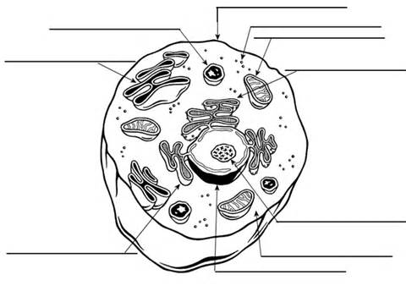

|  |  |  |
| --- | --- | --- |
| ORGANELLE | **DIAGRAM LOCATION (LETTER)** | **FUNCTION** |
| Cell (plasma)membrane |  |  |
| Ribosomes |  |  |
| Cytoplasm |  |  |
| Golgi complex |  |  |
| Lysosome |  |  |
| Mitochondria |  |  |
| Nucleus |  |  |
| Endoplasmic reticulum |  |  |
| DNA material |  |  |

1. List differences between animal and plant cells.
2. Describe the structure of bacterial cell.
3. Explain the significance of surface to volume ratio.