TEST CELLS

1. Which of the following is a characteristic of organelles?
A. They are only found in eukaryotic cells
B. They are only found in prokaryotic cells
C. They are sub-cellular structures
D. They are all membrane bound
(Total 1 mark)
2. If a red blood cell has a diameter of 8 μm and a student shows it with a diameter of 40 mm in a drawing, what is the magnification of the drawing?
A. × 0.0002 B. × 0.2 C. × 5 D. × 5000
(Total 1 mark)
3. Which ratio limits the size of cells?
A. The rate of metabolism to mass B. The surface area to volume
C. The mass to volume D. The surface area to mass
(Total 1 mark)
4. What is the correct order of increasing size for the following biological structures?
I. The width of a virus
II. The width of a bacterium
III. The thickness of a cell surface membrane
IV. The diameter of a eukaryotic cell
A. I → III → II → IV B. I → III → IV → II C. III → I → II → IV D. III → II → I → IV
(Total 1 mark)
5. What is essential for diffusion?
A. A concentration gradient B. A selectively permeable membrane
C. A source of energy D. A protein
(Total 1 mark)
6. Which pair of characteristics are correct for the cellular processes of exocytosis and endocytosis?
 | Exocytosis | Endocytosis
A. | Secretion of cellular materials | Vesicles are moved away from the plasma membrane
B. | Cell membranes fuse | Vesicles are moved towards the plasma membrane
C. | Infolding of plasma membrane | Vesicles are moved away from the plasma membrane
D. | Vesicles moved towards the plasmamembrane | Plasma membrane increases in size
(Total 1 mark)
7. The diagram shows a model of a biological membrane. What do labels I, II, and III illustrate?
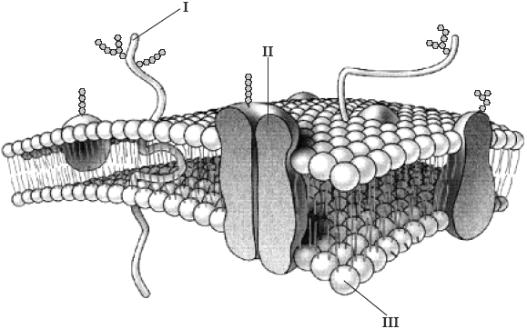
 | I | II | III
A. | Integral protein | Peripheral protein | Hydrophobic phosphate head
B. | Peripheral protein | Glycoprotein | Hydrophilic phosphate head
C. | Glycoprotein | Integral protein | Hydrophilic phosphate head
D. | Glycoprotein | Peripheral protein | Hydrophobic phosphate head
(Total 1 mark)
8. Which of the following is a feature of exocytosis but not endocytosis?
A. Shape changes of a membrane B. Vesicle formation
C. Use of ATP D. Secretion
(Total 1 mark)

Paper 2
1. (a) Distinguish between diffusion and osmosis.
(1)

(b) Explain how the properties of phospholipids help to maintain the structure of the cell surface membrane.

(2)
(Total 3 marks)
2. (a) An organelle is a discrete structure within a cell with a specific function. In the table below, identify the missing organelles and outline the missing functions.
Name of  organelle | Structure of organelle | Function of organelle
Nucleus | Region of the cell containing chromosomes, surrounded by a double membrane, in which there are pores. | Storage and protection of  chromosomes
Ribosome | Small spherical structures, consisting of two subunits.
.................. | Spherical organelles, surrounded by a single membrane and  containing hydrolytic enzymes. | Digestion of structures that are not needed within cells.
.................. | Organelles surrounded by two membranes, the inner of which is folded inwards.
(4)
(b) The table above shows some of the organelles found in a particular cell. Discuss what type of cell this could be.
.....................................................................................................................................
.....................................................................................................................................
(2)
(Total 6 marks)

3. A study was carried out to determine the relationship between the diameter of a molecule and its movement through a membrane. The graph below shows the results of the study.
(a) From the information in the graph alone, describe the relationship between the diameter of a molecule and its movement through a membrane.
(2)

A second study was carried out to investigate the effect of passive protein channels on the movement of glucose into cells. The graph below shows the rate of uptake of glucose into erythrocytes by simple diffusion and facilitated diffusion.
(b) Identify the rate of glucose uptake at an external glucose concentration of 4 mmol dm–3 by
(i) simple diffusion; .........................................
(1)
(ii) facilitated diffusion. .........................................
(1)
(c) (i) Compare the effect of increasing the external glucose concentration on glucose uptake by facilitated diffusion and by simple diffusion.
...........................................................................................................................
...........................................................................................................................
...........................................................................................................................
...........................................................................................................................
(3)
(ii) Predict, with a reason, the effect on glucose uptake by facilitated diffusion of increasing the external concentration of glucose to 30 mmol dm–3.
...........................................................................................................................
...........................................................................................................................
...........................................................................................................................
(2)
(Total 9 marks)

- Outline the stages of mitosis of an animal cell with a chromosome number of four.
 | Diagram | Outline
Prophase | 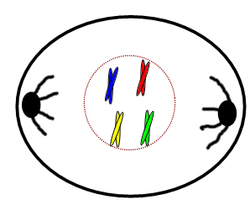
Metaphase
Anaphase
Telophase
- Cancer is an increasing global health concern, related to problems with cell division.

- Define tumour.

- State the locations or tissues where tumours: ii)Can possibly occur. III) Are most likely to occur

Paper 1 – Cells, membranes, 29.09.2010.
1.C 2.D 3.B 4.C 5.A 6.A 7.C 8.D
Paper 2 – Cells, membranes, 29.09.2010.
1. (a) Must have both for [1].
diffusion is the movement of molecules from an area of high concentration to an area of low concentration;osmosis is the diffusion of water across a partially permeable membrane; 1
(b) hydrophillic head groups point outward; hydrophobic tails form a lipid bilayer;
forms a (phospholipid) bilayer;ions and polar molecules cannot pass through
hydrophobic barrier;helps the cell maintain internal concentration
and exclude other molecules; 2 max
(c) cellulose;structural support / protection / maintain turgor pressure; 2
[5]
2. (a) translates RNA into / synthesises polypeptides / proteins;lysosomes; mitochondria;
aerobic respiration / production of ATP;Do not accept production of energy. 4
(b) eukaryotic;membrane bound organelles / nucleus (as reason for being a eukaryote)
could be plant or animal;probably animal because of the lysosomes; 2 max
[6]
3. (a) as the diameter of the molecule increases the permeability / relative ability
to move decreases (accept converse);the relationship is logarithmic / non-linear / negative;for molecules above 0.6 (± 0.1) nm relative ability to move changes little /
for molecules below 0.6 (± 0.1) nm relative ability to move changes rapidly; 2 max
(b)
(i) 10 mmol cm–3 cells hr–1 (accept values within ±5); 1
(ii) 370 mmol cm–3 cells hr–1 (accept values within ± 10); 1
(c) (i) glucose uptake in facilitated diffusion levels out whereas uptake in simple
diffusion does not level out / continues to rise;
glucose uptake increases in both;
glucose uptake is higher in facilitated diffusion (than in simple diffusion);
glucose uptake in simple diffusion is constant / linear whereas in
facilitated diffusion uptake increases rapidly at the beginning / increase
is not constant; 3 max
(ii) little / no change in glucose uptake;
most / all (protein) channels in use; 2
[9]

