How does a generator works?

Take a length of wire, hook it up to an [ammeter](http://www.explainthatstuff.com/movingcoilmeters.html) (something that measures current), and place it between the poles of a magnet. Now move the wire sharply through the invisible [magnetic field](http://www.explainthatstuff.com/magnetism.html) the magnet produces and a current will briefly flow through the wire (registering on the meter). This is the basic science behind the electricity generator, demonstrated in 1831 by British scientist [Michael Faraday](http://en.wikipedia.org/wiki/Michael_Faraday). If you move the wire in the opposite direction, you generate a current that flows the other way. (If you're interested, you can figure out the direction in which the current flows using something called the [right-hand rule](http://hyperphysics.phy-astr.gsu.edu/hbase/magnetic/magfor.html#c3) or generator rule, which is the mirror image of the left-hand rule used to figure out how motors work.)

The important thing to notice is that you generate a current *only when you move the wire* through the magnetic field (or when you move a magnet past a wire, which amounts to the same thing). It's not enough just to place a wire near a magnet: to generate electricity, either the wire has to move past the magnet or vice-versa. Suppose you want to generate lots of electricity. Lifting a wire up and down all day isn't going to be much fun—so you need to devise some way of moving a wire past a magnet by mounting one or the other of them on a wheel. Then, when you turn the wheel, the wire and magnet will move with respect to one another and an electric current will be produced.

Now here's the interesting part. Suppose you bend a wire into a loop, sit it between the poles of a magnet, and arrange it so it will constantly rotate—as in the diagram here. You can probably see that as you turn the loop, each side of the wire (either the orange side or the green side) will sometimes be moving up and sometimes moving down. When it's moving up, electricity will flow one way; when it's moving down, the current will flow the other way. So a basic generator like this will produce an electric current that reverses direction every time the loop of wire flips over (in other words, an alternating current or AC). However, most simple generators actually produce direct current—so how do they manage it?

**DC generators**

Just as a simple DC electric motor uses direct current (DC) electricity to produce continual, rotary motion, so a simple DC generator produces a steady supply of direct current electricity when it spins around. Like a DC motor, a DC generator uses a **commutator**. It sounds technical, but it's just a metal ring with splits in it that periodically reverses the electrical contacts from the generator coil, reversing the current at the same time. As we saw up above, a simple loop of wire automatically reverses the current it produces every half-turn, simply because it's rotating, and the commutator's job is to cancel out the effect of the coil's rotation, ensuring that a direct current is produced.

**AC Alternators**

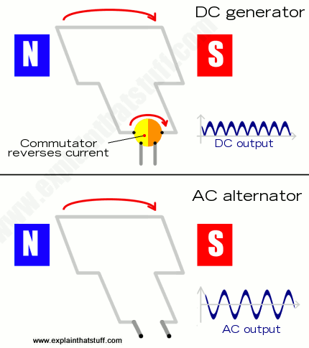 What if you want to generate alternating current (AC) instead of direct current? Then you need an **alternator**, which is simply an AC generator*. The simplest kind of alternator is like a DC generator without a commutator*. As the coil or magnets spin past one another, the current naturally rises, falls, and reverses, giving an AC output. Just as there are [AC induction motors](http://www.explainthatstuff.com/induction-motors.html), which use electromagnets to produce a rotating magnetic field instead of permanent magnets, so there are alternators that work by induction in a similar way.

**Comparing the simplest DC generator with the simplest AC alternator.**

In this design, the coil (gray) spins between the poles of a permanent magnet. Each time it rotates through a half-turn, the current it generates reverses. In the DC generator (top), a commutator reverses the current every time the coil moves a half-turn, cancelling out the reversal of the current. In the AC alternator (bottom), there is no commutator so the output simply rises, falls, and reverses as the coil rotates. You can see the output current from each type of generator in the chart on the right.

**Fleming’s right hand rule**

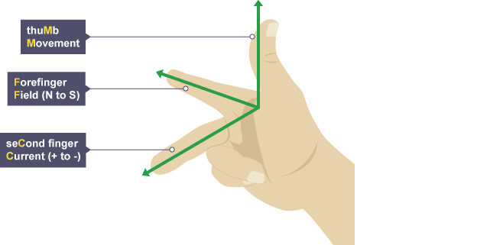

When a wire is moved in the magnetic field of a  [**generator**](http://www.bbc.co.uk/education/guides/z22v4wx/revision/2#glossary-zqtjhyc), the movement, magnetic field and [**current**](http://www.bbc.co.uk/education/guides/z22v4wx/revision/2#glossary-zrmkmp3) are all at right angles to each other. If the wire is moved in the opposite direction, the [**induced**](http://www.bbc.co.uk/education/guides/z22v4wx/revision/2#glossary-z96r7ty) current also moves in the opposite direction.

Alternators are mostly used for generating electricity from vehicle engines.