**Practice paper, Genetics, SL, P2**

**1.** *Up to two additional marks are available for the construction of your answers.*

**(2)**

(b) Explain, using an example, how females but not males can be carriers of some recessive alleles.

(4)

(c) Explain the causes and consequences of sickle-cell anemia.

(5)

(Total 9 marks)

**2.** Rhesus factor is an antigen present on the surface of red blood cells of Rhesus positive individuals.  
Rhesus positive (Rh+ ) is dominant to Rhesus negative (Rh– ). A mother with Rhesus negative blood gives birth to a baby with Rhesus positive blood and there are concerns that subsequent pregnancies will trigger an immune response.

What are the genotypes of the mother and her first baby?

|  |  |  |
| --- | --- | --- |
|  | **Genotype of mother** | **Genotype of first baby** |
| A. | Rh– Rh– | Rh– Rh– |
| B. | Rh– Rh– | Rh+ Rh– |
| C. | Rh– Rh– | Rh+ Rh+ |
| D. | Rh+ Rh– | Rh+ Rh+ |

(Total 1 mark)

**3.** Rice (*Oryza sativa*) is usually intolerant to sustained submergence under water, although it grows rapidly in height for a few days before dying. This is true for one variety, *Oryza sativa japonica*. The variety *Oryza sativa indica* is much more tolerant to submergence.

Three genetically modified forms of *O. sativa japonica*, GMFA, GMFB and GMFC, were made using different fragments of DNA taken from *O. sativa indica*.

The plants were then submerged for a period of 11 days. The heights of all the plants were measured at the beginning and at the end of the submergence period.

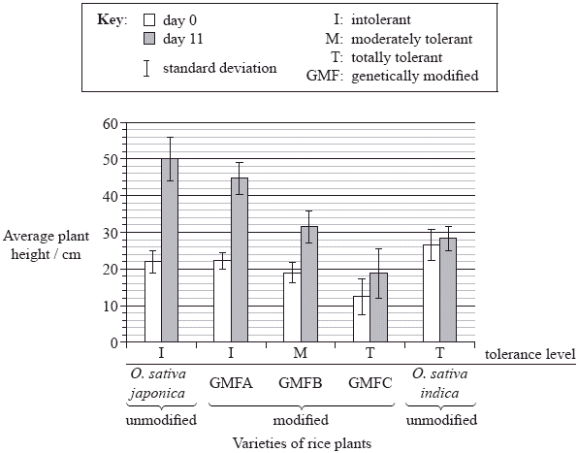

[Adapted by permission from Macmillan Publishers Ltd, Xu et al. 2006. “Sub1A is an ethylene-response-factor-like gene that confers submergence tolerance to rice.” *Nature*. Vol 442. Pp 705–708. Copyright 2006. http://www.nature.com/]

(a) (i) State which group of rice plants were the shortest at the beginning of the experiment.

...........................................................................................................................

(1)

(ii) Calculate the percentage change in height for the *O. sativa japonica* unmodified variety during the submergence period. Show your working.

...........................................................................................................................

...........................................................................................................................

...........................................................................................................................

...........................................................................................................................

...........................................................................................................................

(2)

(b) Explain how the error bars can be used to compare the results for *O. sativa indica*.

......................................................................................................................................

......................................................................................................................................

......................................................................................................................................

......................................................................................................................................

......................................................................................................................................

(2)

(c) Deduce the general relationship between the growth of all the *japonica* varieties and their stated tolerance level.

......................................................................................................................................

......................................................................................................................................

(1)

In the same experiment, the researchers hypothesized that the capacity to survive when submerged is related to the presence of three genes very close to each other on rice chromosome number 9; these genes were named *Sub1A*, *Sub1B* and *Sub1C*. The photograph below of part of a gel shows relative amounts of messenger RNA produced from these three genes by the submergence-intolerant variety, *O.  sativa japonica*, and by the submergence-tolerant variety, *O. sativa indica*, at different times of a submergence period, followed by a recovery period out of water.

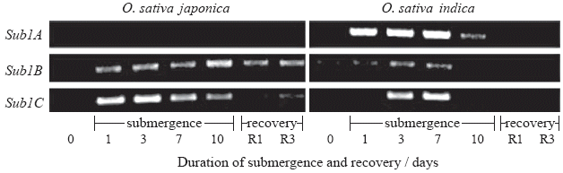

[Adapted by permission from Macmillan Publishers Ltd, Xu et al. 2006. “Sub1A is an ethylene-response-factor-like gene that confers submergence tolerance to rice.” *Nature*. Vol 442. Pp 705–708. Copyright 2006. http://www.nature.com/]

(e) (i) Determine which gene produced the most mRNA on the first day of the submergence period for variety *O. sativa japonica*.

...........................................................................................................................

(1)

(ii) Outline the difference in mRNA production for the three genes during the submergence period for variety *O. sativa indica*.

...........................................................................................................................

...........................................................................................................................

...........................................................................................................................

...........................................................................................................................

(2)

(iii) Compare the mRNA production for the three genes during the submergence period between the two varieties.

...........................................................................................................................

...........................................................................................................................

...........................................................................................................................

...........................................................................................................................

(2)

(g) Evaluate, using all the data, how modified varieties of rice could be used to overcome food shortages in some countries.

......................................................................................................................................

......................................................................................................................................

......................................................................................................................................

......................................................................................................................................

......................................................................................................................................

......................................................................................................................................

(2)

(Total 17 marks)

**4.** Genetic engineering allows genes for resistance to pest organisms to be inserted into various crop plants. Bacteria such as *Bacillus thuringiensis* (Bt) produce proteins that are highly toxic to specific pests.

Stem borers are insects that cause damage to maize crops. In Kenya, a study was carried out to see which types of Bt genes and their protein products would be most efficient against three species of stem borer. The stem borers were allowed to feed on nine types of maize (A–I), modified with Bt genes. The graph below shows the leaf areas damaged by the stem borers after feeding on maize leaves for five days.

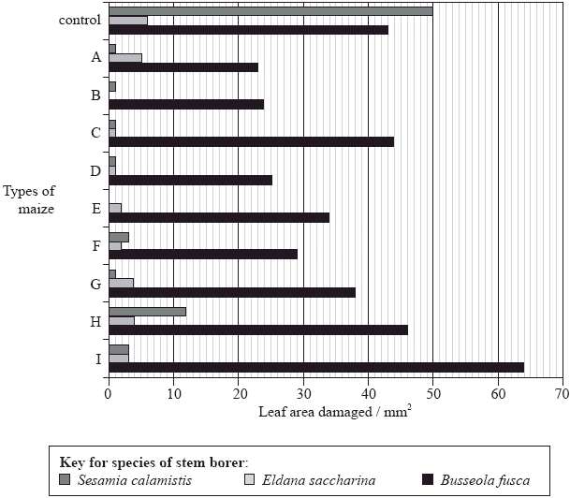

[Source: adapted from S Mugo, *et al*., (2005), *African Journal of Biotechnology*, **4**(13), pages 1490–1504]

(a) (i) State what would be used as the control in this experiment.

...........................................................................................................................

...........................................................................................................................

(1)

(ii) Calculate the percentage difference in leaf area damaged by *Sesamia calamistis* between the control and maize type H. Show your working.

...........................................................................................................................

...........................................................................................................................

...........................................................................................................................

...........................................................................................................................

(2)

(b) Outline the effects of the three species of stem borer on Bt maize type A.

......................................................................................................................................

......................................................................................................................................

......................................................................................................................................

......................................................................................................................................

(2)

(c) Evaluate the efficiency of the types of Bt maize studied, in controlling the three species of stem borers.

......................................................................................................................................

......................................................................................................................................

......................................................................................................................................

......................................................................................................................................

(2)

Before the use of genetically modified maize as a food source, risk assessment must be carried out. A 90-day study was carried out in which 3 groups of 12 adult female rats were fed either:

• seeds from a Bt maize variety

• seeds from the original non-Bt maize variety

• commercially prepared rat food.

All the diets had similar nutritional qualities.

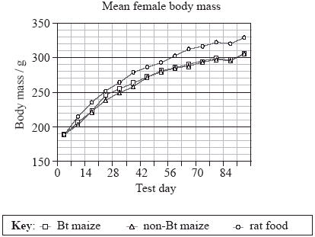

[Source: Linda A. Malley et al. 2007. “Subchronic feeding study of DAS-59122-7 maize grain in Sprague-Dawley rats”. *Food and Chemical Toxicology*. Vol 45, issue 7. Pp 1277­–1292. © Elsevier. Reproduced with permission]

(d) Calculate the change in mean mass of female rats fed on Bt maize from day 14 to 42.

......................................................................................................................................

......................................................................................................................................

(1)

(e) Describe the change in mean mass for the female rats during the 90-day experiment.

......................................................................................................................................

......................................................................................................................................

......................................................................................................................................

(2)

(f) Evaluate the use of Bt maize as a food source compared to the other diets tested.

......................................................................................................................................

......................................................................................................................................

......................................................................................................................................

......................................................................................................................................

(3)

(Total 13 marks)

**5.** The karyotype below shows the chromosomes from a person with Down syndrome.

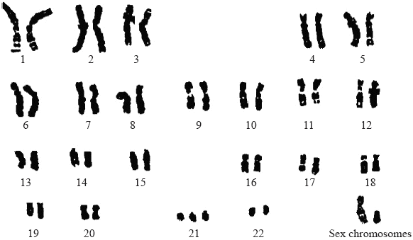

[Source: U.S. Department of Energy Human Genome Program (genomics.energy.gov, genomicscience.energy.gov)]

(a) State the evidence provided by the karyotype that shows this person has Down syndrome.

......................................................................................................................................

(1)

(b) Outline how Down syndrome occurs due to meiosis.

......................................................................................................................................

......................................................................................................................................

......................................................................................................................................

(2)

(c) Determine, giving a reason, the sex of the person in the karyotype.

......................................................................................................................................

......................................................................................................................................

(1)

(d) Explain briefly why males are more likely to inherit colour blindness than females.

......................................................................................................................................

......................................................................................................................................

......................................................................................................................................

......................................................................................................................................

(2)

(Total 6 marks)

**6.** The following sequence of pictures, made using an electronic imaging technique, shows a cell undergoing division.

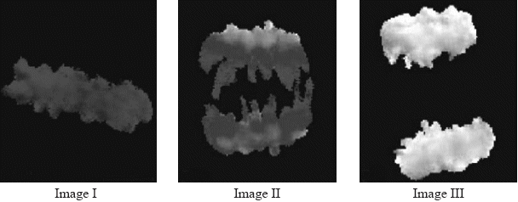

[Adapted by permission from Macmillan Publishers Ltd, Fuller, B G et al. 2008. “Midzone activation of aurora B in anaphase produces an intracellular phosphorylation gradient”. *Nature.* Vol 453.]

(a) State the stage of mitosis typified by image II.

......................................................................................................................................

(1)

(b) List **two** processes that involve mitosis.

......................................................................................................................................

......................................................................................................................................

(2)

(c) State the process that results in tumour (cancer) formation or development.

......................................................................................................................................

(1)

(d) Explain, using **one** example, how non-disjunction in meiosis can lead to changes in chromosome number.

......................................................................................................................................

......................................................................................................................................

......................................................................................................................................

......................................................................................................................................

(2)

(Total 6 marks)

**7.**

(b) A boy inherited red-green colour-blindness from one of his grandfathers. Deduce, giving your reasons, which of his two grandfathers was also colour-blind.

.....................................................................................................................................

.....................................................................................................................................

.....................................................................................................................................

.....................................................................................................................................

.....................................................................................................................................

.....................................................................................................................................

(3)

(Total 4 marks)