**1.** The diagram below shows a pair of chromosomes during meiosis in a cell in the human testis.  
The position of the alleles of some genes is indicated.

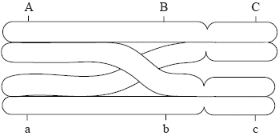

(a) Deduce, with reasons for your answer, whether the chromosomes are

(i) autosomes or sex chromosomes.

...........................................................................................................................

...........................................................................................................................

(1)

(ii) homologous or non-homologous.

...........................................................................................................................

...........................................................................................................................

(1)

(b) State the stage of meiosis of a cell if it contains pairs of chromosomes as shown in the diagram.

......................................................................................................................................

(1)

(c) At the end of meiosis, each of the chromatids shown in the diagram will be in a different haploid cell. The diagrams below represent the chromatids inside the haploid cells.  
Determine the combinations of alleles that would be present on each chromatid. Use the diagrams to indicate your answer.

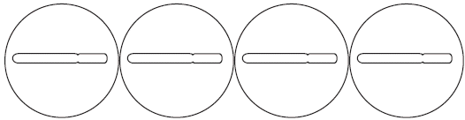

(2)

(d) State the pattern of inheritance shown by the three genes.

......................................................................................................................................

(1)

(Total 6 marks)

**2.** In the red squirrel (*Tamiasciurus hudsonicus*), the allele for grey fur colour (G) is dominant to the allele for red fur colour (g) and the allele for a fluffy tail (F) is dominant to hairless tail (f).

(a) The genes described above form a linkage group. Define *linkage group*.

......................................................................................................................................

......................................................................................................................................

(1)

(b) A cross is made between squirrels of the following genotypes.



Using a similar format, identify the genotypes of offspring which are recombinants.

......................................................................................................................................

(2)

(c) Explain how the recombinants are formed during meiosis.

......................................................................................................................................

......................................................................................................................................

......................................................................................................................................

......................................................................................................................................

......................................................................................................................................

......................................................................................................................................

(3)

(d) Explain the role of transfer RNA (tRNA) in the process of translation.

......................................................................................................................................

......................................................................................................................................

......................................................................................................................................

......................................................................................................................................

......................................................................................................................................

(2)

(Total 8 marks)

**3.** (a) Define the term *polygenic inheritance*.

......................................................................................................................................

......................................................................................................................................

(1)

(b) Explain, using a **named** example, how polygenic inheritance gives rise to continuous variation.

......................................................................................................................................

......................................................................................................................................

......................................................................................................................................

......................................................................................................................................

......................................................................................................................................

(2)

(c) Describe the inheritance of colour blindness in humans.

......................................................................................................................................

......................................................................................................................................

......................................................................................................................................

......................................................................................................................................

......................................................................................................................................

......................................................................................................................................

......................................................................................................................................

......................................................................................................................................

(3)

(Total 6 marks)

**4.** *Up to two additional marks are available for the construction of your answers.*

**(2)**

(a) Describe the causes of Down syndrome.

(5)

(b) Describe how human skin colour is determined genetically.

(5)

(c) Explain the causes of sickle-cell anemia.

(8)

(Total 20 marks)

**5.** (a) In some maize plants the seed is enclosed in a green sheath called a tunica.  
The allele (T) for this is dominant to the allele (t) for normal, unenclosed seeds.  
The endosperm of the seed can be starchy (allele E) or sugary (allele e). The genes for these two characteristics are linked. The table below shows the outcome of crosses between a plant heterozygous for both characteristics and one that is homozygous recessive for both characteristics.

|  |  |
| --- | --- |
| **Phenotype** | **Number** |
| Tunica present, starchy | 326 |
| Unenclosed seeds, starchy | 111 |
| Tunica present, sugary | 118 |
| Unenclosed seeds, sugary | 295 |

(i) State the genotype of the heterozygous parent using the correct notation.

...........................................................................................................................

...........................................................................................................................

(1)

(ii) Identify which individuals are recombinants in this cross.

...........................................................................................................................

...........................................................................................................................

(1)

(iii) Explain what has occurred to cause these results.

...........................................................................................................................

...........................................................................................................................

...........................................................................................................................

...........................................................................................................................

...........................................................................................................................

...........................................................................................................................

(2)

(b) Maize belongs to the group of plants known as angiospermophyta. Distinguish between angiospermophytes and bryophytes.

......................................................................................................................................

......................................................................................................................................

......................................................................................................................................

......................................................................................................................................

......................................................................................................................................

......................................................................................................................................

(2)

(Total 6 marks)

**6.** *Up to two additional marks are available for the construction of your answers.*

**(2)**

(a) Draw a labelled diagram of a mature sperm.

(5)

(b) Outline the formation of chiasmata during crossing over.

(5)

(c) Explain how an error in meiosis can lead to Down syndrome.

(8)

(Total 20 marks)

**7.** (a) Outline a possible cause of Down syndrome.

(4)

(b) Outline the processes involved in oogenesis within the human ovary.

(8)

(c) Discuss the ethical issues surrounding IVF.

(6)

(Total 18 marks)

**8.** *Up to two additional marks are available for the construction of your answers.*

**(2)**

(a) Embryos that are produced by *in vitro* fertilization can be screened for genetic disease.  
Outline the process of *in vitro* fertilization, including **one** example of a situation when it is used.

(9)

(b) Explain, using an example, how females but not males can be carriers of some recessive alleles.

(4)

(c) Explain the causes and consequences of sickle-cell anemia.

(5)

(Total 20 marks)

**9.** Rhesus factor is an antigen present on the surface of red blood cells of Rhesus positive individuals.  
Rhesus positive (Rh+ ) is dominant to Rhesus negative (Rh– ). A mother with Rhesus negative blood gives birth to a baby with Rhesus positive blood and there are concerns that subsequent pregnancies will trigger an immune response.

What are the genotypes of the mother and her first baby?

|  |  |  |
| --- | --- | --- |
|  | **Genotype of mother** | **Genotype of first baby** |
| A. | Rh– Rh– | Rh– Rh– |
| B. | Rh– Rh– | Rh+ Rh– |
| C. | Rh– Rh– | Rh+ Rh+ |
| D. | Rh+ Rh– | Rh+ Rh+ |

(Total 1 mark)

**10.** Rice (*Oryza sativa*) is usually intolerant to sustained submergence under water, although it grows rapidly in height for a few days before dying. This is true for one variety, *Oryza sativa japonica*. The variety *Oryza sativa indica* is much more tolerant to submergence.

Three genetically modified forms of *O. sativa japonica*, GMFA, GMFB and GMFC, were made using different fragments of DNA taken from *O. sativa indica*.

The plants were then submerged for a period of 11 days. The heights of all the plants were measured at the beginning and at the end of the submergence period.

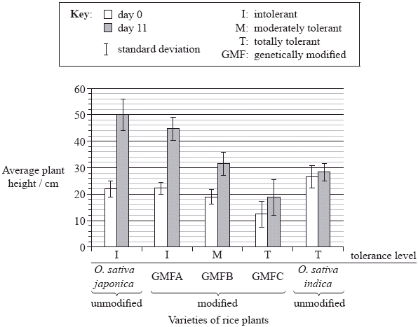

[Adapted by permission from Macmillan Publishers Ltd, Xu et al. 2006. “Sub1A is an ethylene-response-factor-like gene that confers submergence tolerance to rice.” *Nature*. Vol 442. Pp 705–708. Copyright 2006. http://www.nature.com/]

(a) (i) State which group of rice plants were the shortest at the beginning of the experiment.

...........................................................................................................................

(1)

(ii) Calculate the percentage change in height for the *O. sativa japonica* unmodified variety during the submergence period. Show your working.

...........................................................................................................................

...........................................................................................................................

...........................................................................................................................

...........................................................................................................................

...........................................................................................................................

(2)

(b) Explain how the error bars can be used to compare the results for *O. sativa indica*.

......................................................................................................................................

......................................................................................................................................

......................................................................................................................................

......................................................................................................................................

......................................................................................................................................

(2)

(c) Deduce the general relationship between the growth of all the *japonica* varieties and their stated tolerance level.

......................................................................................................................................

......................................................................................................................................

(1)

(d) Outline the use of the binomial system of nomenclature in *Oryza sativa*.

......................................................................................................................................

......................................................................................................................................

......................................................................................................................................

......................................................................................................................................

(2)

In the same experiment, the researchers hypothesized that the capacity to survive when submerged is related to the presence of three genes very close to each other on rice chromosome number 9; these genes were named *Sub1A*, *Sub1B* and *Sub1C*. The photograph below of part of a gel shows relative amounts of messenger RNA produced from these three genes by the submergence-intolerant variety, *O.  sativa japonica*, and by the submergence-tolerant variety, *O. sativa indica*, at different times of a submergence period, followed by a recovery period out of water.

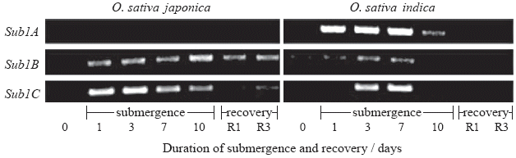

[Adapted by permission from Macmillan Publishers Ltd, Xu et al. 2006. “Sub1A is an ethylene-response-factor-like gene that confers submergence tolerance to rice.” *Nature*. Vol 442. Pp 705–708. Copyright 2006. http://www.nature.com/]

(e) (i) Determine which gene produced the most mRNA on the first day of the submergence period for variety *O. sativa japonica*.

...........................................................................................................................

(1)

(ii) Outline the difference in mRNA production for the three genes during the submergence period for variety *O. sativa indica*.

...........................................................................................................................

...........................................................................................................................

...........................................................................................................................

...........................................................................................................................

(2)

(iii) Compare the mRNA production for the three genes during the submergence period between the two varieties.

...........................................................................................................................

...........................................................................................................................

...........................................................................................................................

...........................................................................................................................

(2)

(f) Deduce, using all the data, which gene was used to modify GMFC.

......................................................................................................................................

......................................................................................................................................

......................................................................................................................................

......................................................................................................................................

(2)

(g) Evaluate, using all the data, how modified varieties of rice could be used to overcome food shortages in some countries.

......................................................................................................................................

......................................................................................................................................

......................................................................................................................................

......................................................................................................................................

......................................................................................................................................

......................................................................................................................................

(2)

(Total 17 marks)

**11.** The karyotype below shows the chromosomes from a person with Down syndrome.

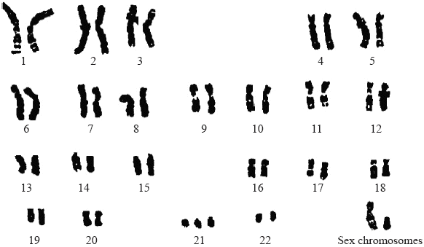

[Source: U.S. Department of Energy Human Genome Program (genomics.energy.gov, genomicscience.energy.gov)]

(a) State the evidence provided by the karyotype that shows this person has Down syndrome.

......................................................................................................................................

(1)

(b) Outline how Down syndrome occurs due to meiosis.

......................................................................................................................................

......................................................................................................................................

......................................................................................................................................

(2)

(c) Determine, giving a reason, the sex of the person in the karyotype.

......................................................................................................................................

......................................................................................................................................

(1)

(d) Explain briefly why males are more likely to inherit colour blindness than females.

......................................................................................................................................

......................................................................................................................................

......................................................................................................................................

......................................................................................................................................

(2)

(Total 6 marks)

**12.** The following sequence of pictures, made using an electronic imaging technique, shows a cell undergoing division.

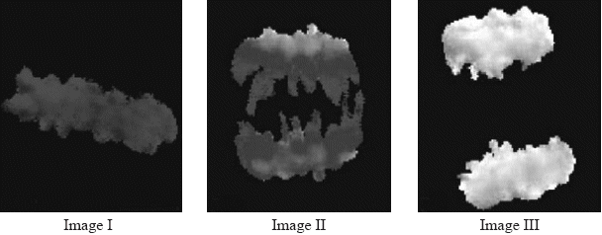

[Adapted by permission from Macmillan Publishers Ltd, Fuller, B G et al. 2008. “Midzone activation of aurora B in anaphase produces an intracellular phosphorylation gradient”. *Nature.* Vol 453.]

(a) State the stage of mitosis typified by image II.

......................................................................................................................................

(1)

(b) List **two** processes that involve mitosis.

......................................................................................................................................

......................................................................................................................................

(2)

(c) State the process that results in tumour (cancer) formation or development.

......................................................................................................................................

(1)

(d) Explain, using **one** example, how non-disjunction in meiosis can lead to changes in chromosome number.

......................................................................................................................................

......................................................................................................................................

......................................................................................................................................

......................................................................................................................................

(2)

(Total 6 marks)

**13.** (a) List **two** roles of testosterone in males.

1. ..........................................................................................................................

2. ..........................................................................................................................

(1)

(b) A boy inherited red-green colour-blindness from one of his grandfathers. Deduce, giving your reasons, which of his two grandfathers was also colour-blind.

.....................................................................................................................................

.....................................................................................................................................

.....................................................................................................................................

.....................................................................................................................................

.....................................................................................................................................

.....................................................................................................................................

(3)

(Total 4 marks)