**1.** Which of the following statements about homologous chromosomes is correct?

A. Each gene is at the same locus on both chromosomes.

B. They are two identical copies of a parent chromosome which are attached to one another at the centromere.

C. They always produce identical phenotypes.

D. They are chromosomes that have identical genes and alleles.

(Total 1 mark)

**2.** What happens in crossing over?

A. Exchange of genetic material between homologous chromosomes

B. Exchange of genes during metaphase of mitosis

C. Random distribution of chromosomes during meiosis

D. Homologous chromosomes fail to separate during meiosis

(Total 1 mark)

**3.** The pedigree chart below shows the blood types of three members of a family.

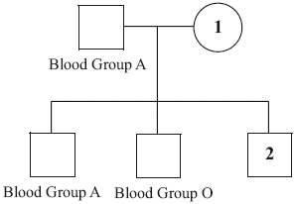

Which could be the blood types of individuals 1 and 2?

|  |  |  |
| --- | --- | --- |
|  | **Individual 1** | **Individual 2** |
| A. | A | AB |
| B. | AB | B |
| C. | O | B |
| D. | B | A |

(Total 1 mark)

**4.** Which of the following types of information are needed to construct a karyotype?

I. Size of the chromosomes

II. Gene mutations of the chromosomes

III. Age of the individual

A. I only

B. II only

C. I and II only

D. I, II and III

(Total 1 mark)

**5.** A woman who is a carrier for hemophilia and a man who does not have hemophilia have a child.  
What is the probability that the child will have hemophilia?

|  |  |  |
| --- | --- | --- |
|  | **If it is a girl** | **If it is a boy** |
| A. | 0% | 50% |
| B. | 0% | 0% |
| C. | 50% | 50% |
| D. | 50% | 0% |

(Total 1 mark)

**6.** Which enzymes are needed to produce recombinant plasmids to be used in gene transfer?

A. DNA polymerase and DNA ligase

B. DNA polymerase and restriction enzyme (endonuclease)

C. Transcriptase and RNA polymerase

D. Restriction enzyme (endonuclease) and DNA ligase

(Total 1 mark)

**7.** A human cell has between 20 000 and 25 000 genes whereas an *E. coli* cell has approximately 4000 genes. Which of the following statements is true?

A. The human genome is larger than the *E. coli* genome.

B. There are more genes on each human chromosome than on the *E. coli* chromosome.

C. The human cell and the *E. coli* cell produce approximately the same variety of proteins.

D. The DNA in both organisms is associated with histones (proteins).

(Total 1 mark)

**8.** In the following diagram, which pair represents homologous chromosomes?

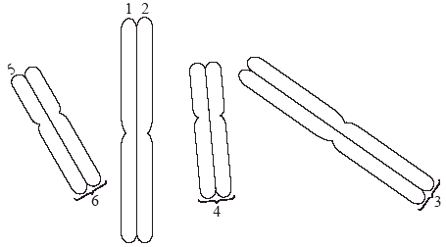

A. 1 and 2

B. 3 and 4

C. 2 and 5

D. 4 and 6

(Total 1 mark)

**9.** A parent organism of unknown genotype is mated in a test cross. Half of the offspring have the same phenotype as the parent. What can be concluded from this result?

A. The parent of unknown genotype is heterozygous.

B. The parent of unknown genotype is homozygous dominant.

C. The parent of unknown genotype is homozygous recessive.

D. The parent of known genotype is heterozygous.

(Total 1 mark)

**10.** Rhesus factor is an antigen present on the surface of red blood cells of Rhesus positive individuals.  
Rhesus positive (Rh+ ) is dominant to Rhesus negative (Rh– ). A mother with Rhesus negative blood gives birth to a baby with Rhesus positive blood and there are concerns that subsequent pregnancies will trigger an immune response.

What is a possible explanation for why subsequent pregnancies could trigger an immune response?

A. Exposure to the Rh+ antigen in the first pregnancy triggered the development of antibodies that could attack the blood of a future Rh+ baby.

B. Exposure to the Rh+ antigen in the first pregnancy triggered the development of specific phagocytes that could attack the blood of a future Rh+ baby.

C. The mother has developed passive immunity to the Rh+ factor.

D. The mother’s immune system has been weakened by pregnancy.

(Total 1 mark)

**11.** A new allele that provides herbicide resistance is identified in soybean plants. The allele is dominant.  
Which of the following would be carried out in a herbicide-resistant plant to find out if it is homozygous or heterozygous for the gene?

A. Gel electrophoresis

B. Karyotyping

C. Test cross

D. DNA profiling

(Total 1 mark)

**12.** What is a suspected heterozygous individual crossed with in a test cross?

A. Homozygous dominant

B. Homozygous recessive

C. Heterozygous dominant

D. Heterozygous recessive

(Total 1 mark)

**13.** Which processes involved in cloning an animal are indicated by the letters X and Y?

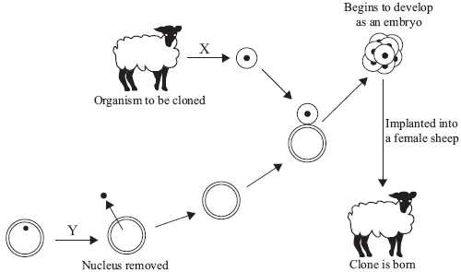

|  |  |  |
| --- | --- | --- |
|  | **X** | **Y** |
| A. | differentiated cell removed from animal | nucleus removed from unfertilized egg cell |
| B. | sex cell removed from animal | nucleus removed from differentiated animal cell |
| C. | sex cell removed from animal | nucleus removed from unfertilized egg cell |
| D. | differentiated cell removed from animal | nucleus removed from differentiated animal cell |

(Total 1 mark)

**14.** What type of inheritance is shown in this pedigree chart?

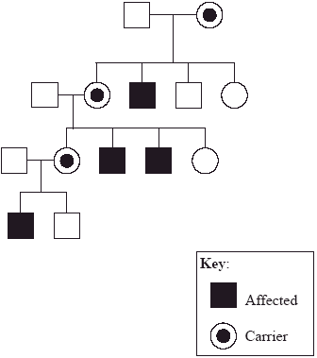

A. X-linked dominant

B. Y-linked dominant

C. X-linked recessive

D. Y-linked recessive

(Total 1 mark)

**15.** Which of the following is the cause of sickle-cell anemia?

A. Tryptophan is replaced by leucine.

B. Leucine is replaced by valine.

C. Glutamic acid is replaced by valine.

D. Lysine is replaced by glutamic acid.

(Total 1 mark)

**16.** What does the karyotype below correspond to?

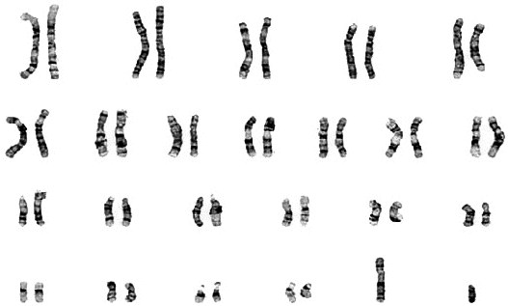

A. A normal male

B. A normal female

C. A female with Down syndrome

D. A male with Down syndrome

(Total 1 mark)

**17.** A man of blood group A and a woman of blood group B have a child. If both are heterozygous for the gene, what are the chances of them having a child with blood group B?

A. 0%

B. 25%

C. 50%

D. 75%

(Total 1 mark)

**18.** Which disease is an example of sex-linked (X-linked) inheritance?

A. AIDS

B. Down syndrome

C. Sickle-cell anemia

D. Hemophilia

(Total 1 mark)

**19.** The diagram below represents the results obtained in a DNA profile from a crime scene.

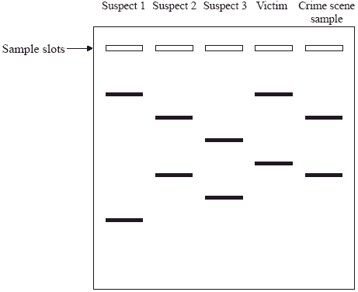

Suspect 2 is **most** likely to be the criminal because the band pattern coincides with that of the crime scene sample. What do these bands represent?

A. DNA fragments

B. Genes

C. Chromosomes

D. Chromatids

(Total 1 mark)

**20.** What is a genetic test cross?

A. Testing a suspected homozygote by crossing it with a known heterozygote

B. Testing a suspected heterozygote by crossing it with a known heterozygote

C. Testing a suspected homozygote by crossing it with a known homozygous dominant

D. Testing a suspected heterozygote by crossing it with a known homozygous recessive

(Total 1 mark)

**21.** A cell in the testis of a male chimpanzee (*Pan troglodytes*) contains 48 chromosomes. It is about to undergo meiosis. How many molecules of DNA will be present in the nucleus of the sperm cells just after meiosis?

A. 96

B. 48

C. 24

D. 12

(Total 1 mark)

**22.** What is chorionic villus sampling?

A. Sampling cells from the placenta

B. Sampling cells from the fetal digestive system

C. Sampling fetal cells from the amniotic fluid

D. Sampling stem cells from the umbilical cord

(Total 1 mark)

**23.** How can fragments of DNA be separated?

A. Using polymerase chain reaction (PCR)

B. Using gel electrophoresis

C. Using gene transfer

D. Using gene cloning

(Total 1 mark)

**24.** Why can DNA profiling be used to determine paternity?

A. Genes of children are exactly the same as their father’s.

B. Half the genes of children are the same as their father’s.

C. The father passes on all of his genes to each of his children.

D. The father passes on a fraction of his genes equal to the number of his children.

(Total 1 mark)

**25.** Which of the following will promote variation in a species?

I. Meiosis

II. Fertilization

III. Natural selection

A. I only

B. II only

C. I and II only

D. I, II and III

(Total 1 mark)

**26.** What is the set of alleles that an individual possesses?

A. A gene

B. A genotype

C. A genome

D. A genus

(Total 1 mark)

**27.** Which phase of cell division is photographed in order to make a karyotype?

A. Anaphase of mitosis

B. Anaphase I of meiosis

C. Metaphase of mitosis

D. Metaphase II of meiosis

(Total 1 mark)

**28.** What evidence is given in the pedigree chart below to establish that the condition is caused by a dominant allele?

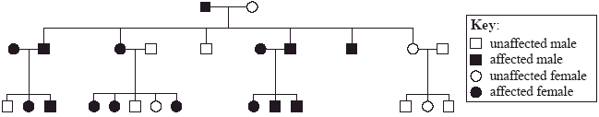

A. Two unaffected parents have unaffected children.

B. Two affected parents have affected children.

C. An affected parent and an unaffected parent have affected children.

D. Two affected parents have an unaffected child.

(Total 1 mark)

**29.** Which process is used in polymerase chain reaction (PCR)?

A. Transcription

B. Translation

C. Replication

D. Mutation

(Total 1 mark)

**30.** What conclusion can be made from the following evidence from an analysis of DNA fragments?

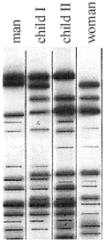

A. Both children are related to both parents.

B. Child I is related to the man but child II is not.

C. Both children are unrelated to either of the parents.

D. Child II is related to the man but child I is not.

(Total 1 mark)

**31.** If the haploid number of a species is 14, how many chromatids will there be in metaphase I in a dividing diploid cell?

A. 7

B. 14

C. 28

D. 56

(Total 1 mark)

**32.** Which enzymes are needed to incorporate genes into plasmids to create recombinant plasmids?

A. DNA polymerase and ligase

B. DNA polymerase and restriction enzymes

C. Restriction enzymes and ligase

D. Helicase and restriction enzymes

(Total 1 mark)

**33.** What could be achieved by DNA profiling using gel electrophoresis?

A. The chromosome number of an organism could be counted.

B. It could be shown that human tissue found at the site of a crime did not come from a person suspected of having committed the crime.

C. A karyotype could be produced.

D. Extinct species of living organisms could be brought back to life.

(Total 1 mark)

**34.** If an organism that is homozygous recessive for a trait is crossed with a heterozygote, what is the chance of getting a homozygous recessive phenotype in the first generation?

A. 0%

B. 25%

C. 50%

D. 100%

(Total 1 mark)

**35.** How are plasmids used in biotechnology?

A. For respiration in prokaryotes

B. For photosynthesis in eukaryotes

C. For protein synthesis in prokaryotes and eukaryotes

D. For gene transfer

(Total 1 mark)

**36.** A parent organism of unknown genotype is mated in a test cross. Half of the offspring have the same phenotype as the parent. What can be concluded from this result?

A. The parent is homozygous dominant for the trait.

B. The trait being inherited is polygenic.

C. The parent is heterozygous for the trait.

D. The parent is homozygous recessive for the trait.

(Total 1 mark)

**37.** What is placed into the uterus after the process of *in vitro* fertilization (IVF)?

A. Eggs

B. Sperm

C. Embryos

D. Fetuses

(Total 1 mark)

**38.** What can be concluded from the karyotype provided below?

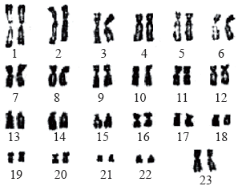

[Source: www.ds-health.com/trisomy.htm]

A. There was non-disjunction during meiosis in the mother.

B. There was non-disjunction during meiosis in the father.

C. The fetus is male.

D. The fetus is female.

(Total 1 mark)

**39.** What is the cause of sickle-cell anemia?

A. A change to the base sequence of a hemoglobin gene

B. Mosquitoes acting as the vector for malaria

C. Iron deficiency due to the malaria parasite

D. Production of more white blood cells than red blood cells by bone marrow

(Total 1 mark)

**40.** The blood groups of a mother and four children are indicated on the pedigree chart below.

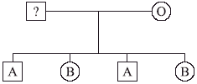

What are the possible blood groups of the father?

A. Group A only

B. Group A or B only

C. Group AB only

D. Group A, B or AB only

(Total 1 mark)

**41.** Boys can inherit the recessive allele (*c*) that causes red-green colour blindness from their mother, not from their father. The allele for normal red and green vision is *C.* Which of the following genotypes are possible in men?

A. *c* only

B. *C* or *c* only

C. *CC* or *cc* only

D. *CC*, *Cc* or *cc* only

(Total 1 mark)

**42.** A small amount of a suspect’s DNA is obtained from a crime scene. What techniques would be used to carry out DNA profiling?

A. Gel electrophoresis and paternity testing

B. Paternity testing and the polymerase chain reaction (PCR)

C. Polymerase chain reaction (PCR) and gel electrophoresis

D. Test crossing and pedigree analysis

(Total 1 mark)

**43.** The Human Genome Project allowed the first accurate estimates of the number of different genes in the human genome. What was a typical estimate, based on the results of the Human Genome Project?

A. 46

B. 64

C. 25 000

D. 1 000 000

(Total 1 mark)

**44.** The diagram below shows the cell of an organism going through the first division of meiosis.



How many different combinations are possible for these chromosomes in the haploid cells formed by meiosis?

A. 2

B. 6

C. 8

D. 9

(Total 1 mark)

**45.** If the amount of DNA in a haploid gamete is represented by , what is the net quantity of DNA in a cell from the same organism at the start of meiosis?

A. 0.5 

B. 

C. 2 

D. 4 

(Total 1 mark)

**46.** If a man has blood group O and a woman has blood group AB, what is the probability that their child will be blood group O?

A. 0%

B. 25%

C. 50%

D. 100%

(Total 1 mark)