14 Excretion and the kidneys - exercises and discussion
Exercises and discussion E3.15

1 Discuss whether or not sweat should be considered as an excretory product. Suggest
arguments both for and against. (A)

2 Undigested food has never been used in your cells; it has merely passed through the
alimentary canal. For this reason, egestion of faeces is not usually included under the heading
of excretion. However, at least one component of the faeces could be considered as an excretory product. Name this component, say where it comes from and why its removal can be regarded as excretion. (A)

3 The heart pumps about 5 litres of blood per minute. At rest, about one-quarter of the heart's output passes through the kidneys. About180 litres of blood-derived liquid (glomerular filtrate) passes out of the glomeruli, into the renal capsules each day.
Use these figures to calculate the percentage volume of blood that is filtered by the kidneys. (I)
urine output/ cm³ per 30 min
4 The graph shows the output of urine in a
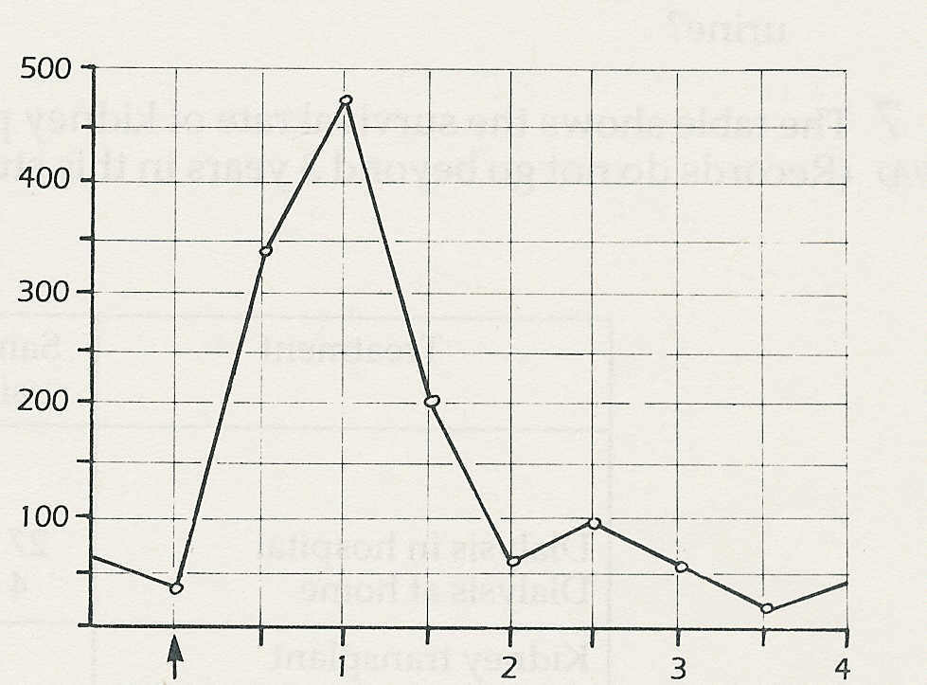
subject after drinking a litre of water.
(a) What is the approximate rate of urine
production in normal circumstances?
(b) What was the maximum rate of urine
output in the course of the experiment?
(c) How long did it take to reach the
maximum rate of urine output?
(d) How long did the subject take to get.
rid of the excess water? (I)
© Bell, Davidson and
Emslie-Smith

1 litre water
drunk
time / hours

5 The graph below shows the volume (solid
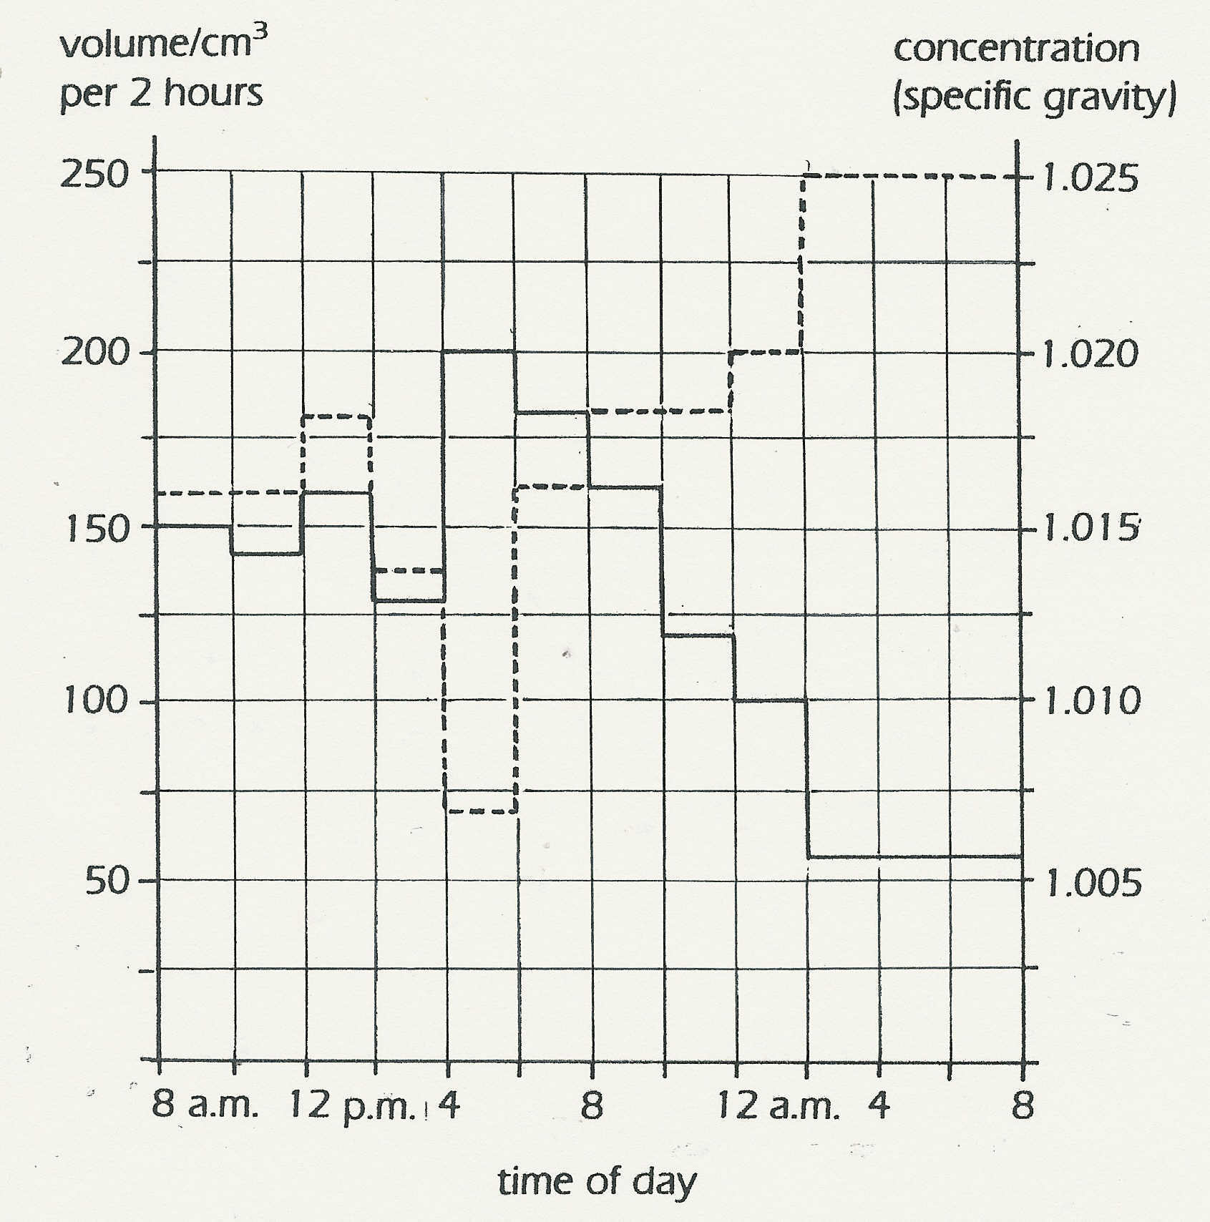
line) and concentration (broken line) of
urine produced in one day.
(a) In general, what is the relationship
between the volume and the
concentration of urine?
(b) Suggest what might have happened
between 12 noon and 2 p.m. to cause
both the volume and the concentration
to increase.
(c) What might have happened between
4 p.m. and 6 p.m. to cause a rise in
volume but decrease in concentration?
(d) Why do you think the concentration
increases so much during the night? (I)

(NOTE. Water has a specific gravity of 1. Values
above this represent an increase in concentration
of solutes)
© Bell, Davidson and Emslie-Smith
Exercises and discussion E3.16
Excretion and the Kidneys - exercises and discussion (continued)

6 The following table shows the
concentration of certain ions in plasma and
in urine. The percentage volume of water is
 | Plasma / g per 100 cm3 | Urine/ g per 100 cm3
Water  Sodium  Potassium  Calcium  Chloride | 90-93  0.32  0.02  0.01  0.37 | 95  0.6  0.15  0.015  0.6
also shown.
Plot the figures for the ions on a bar chart.
Put the values for the plasma and urine
concentrations on the same chart in order
to show the changes clearly.
(a) Are the ions more concentrated in
plasma or in urine?
(b) The increase in concentration cannot
© Bell, Davidson and Emslie Smith
have come about simply by removal of
water. What evidence is there for this?
(c) Which of the ions has increased its
concentration the most?
(d) In what ways might the kidneys
increase .the concentration of ions in
urine? (I)
7 The table shows the survival rate of kidney patients on different forms of treatment.
(NOTE. Records do not go beyond 3years in this study which was conducted some years ago.
The figures in all categories will have improved significantly)
Treatment | Sample size | % survival
Dialysis in hospital  Dialysis at home | 27,495  4,518 | 1 year | 2 years | 3 years
Dialysis in hospital  Dialysis at home | 27,495  4,518 | 87.5  95.3 | 77.0  90.7 | 68.0  84.3
Kidney transplant  from living donor | 833 | 87.5 | 82.2 | 79.4
Kidney transplant from dead donor | 5,782 | 81.1 | 74.9 | 70.6
(a) Which set of figures do you think is the most reliable? Why do you think so?
(b) It seems surprising that the survival rate for dialysis in hospital is lower than for
dialysis at home. Suggest a simple explanation for this difference,
(c) Why, do you think, is the survival rate for transplants greater when the kidney is taken
from a living donor?
(d) Discuss which treatment might be most cost-effective. (I/A)

Exercises and discussion E3.17
Excretion and the kidneys - exercises and discussion (continued)

8 Read the following passage:

Two factors could increase the potential demand for transplants. First the relaxation of age
and fitness criteria for first transplantation (many units have an upper age limit of 55, but this
may change). The second, and very important, factor is the survival rate of transplantees. If
patient survival were to rise but graft survival were to remain the same, the potential demand
for second, third and even subsequent transplants could be very considerably increased.

© Office of Health Economics

Explain, in your own words, the two possible causes of an increased demand for donor
kidneys. Invent examples of age, patient survival and graft survival to illustrate your explanations. (C)

9 A physiologist wants to find out the rate of filtration in the glomeruli of the kidneys. The
best experimental design would be inject a substance which
(a) cannot pass through the glomerular capillaries
(b) can pass through the glomerular capillaries but is totally reabsorbed in the renal
tubules
(c) can pass through the glomerular capillaries and is partially reabsorbed in the renal tubules
(d) can pass through the glomerular capillaries and is not reabsorbed in the renal tubules. (E/A)

10 A researcher wants to find out if a drug affects the volume of urine produced. Suggest an experimental procedure to find out if this is so.

